**Name: Hindu Priya Chandanala**

**Project Title:  Wholesale WareHouse Management System**

**Course name: Advanced Database Systems**

**Course number: CS640**

**Instructor name: Dr. Suhair Amer**

**Store Name: Badrakali Store**

1. **Project description. What you are selling and list the software, tools, programming languages used.**

**Project description:**

My project is on maintaining and managing wholesale warehouse store system website with the database. It keeps track of all the information about stock details, Customers details, Buyers details. It also calculates three types of profit yearly, profit monthly, profit daily. Once the quantity of stock goes less than 10, it is designed to warn about refilling of the stock. It also keeps track of total sales, pending payments, paid payments, list of Customers whose payment is pending.

Here, I am selling medical equipments like

* Ventilators
* Cardiopulmonary bypass device
* Dialysis machine
* Infusion pumps
* LASIK surgical machine
* Medical lasers
* Consult 120 Urine Analyzer
* Urine Reagent Strips 10 Parameter
* Consult Liquid Urine Control
* Plastic urine containers, sterile or unsterile
* Conical centrifuge tube, 15 ml
* Microscope slides and 1 coverslip
* Clinical Centrifuge
* Flow cytometers
* Blood gas analyzers
* Electrolyte analyzers
* Differential counters
* Coagulation analyzers
* Slide strainers
* Magnetic resonance imaging (MRI)

in the store.

**Tools used:** Xampp (Apache, MySQL), Visual Studio Code, MySQL Workbench.

**Programming Languages**: PHP, HTML, SQL, CSS, Javascript

HomePage :

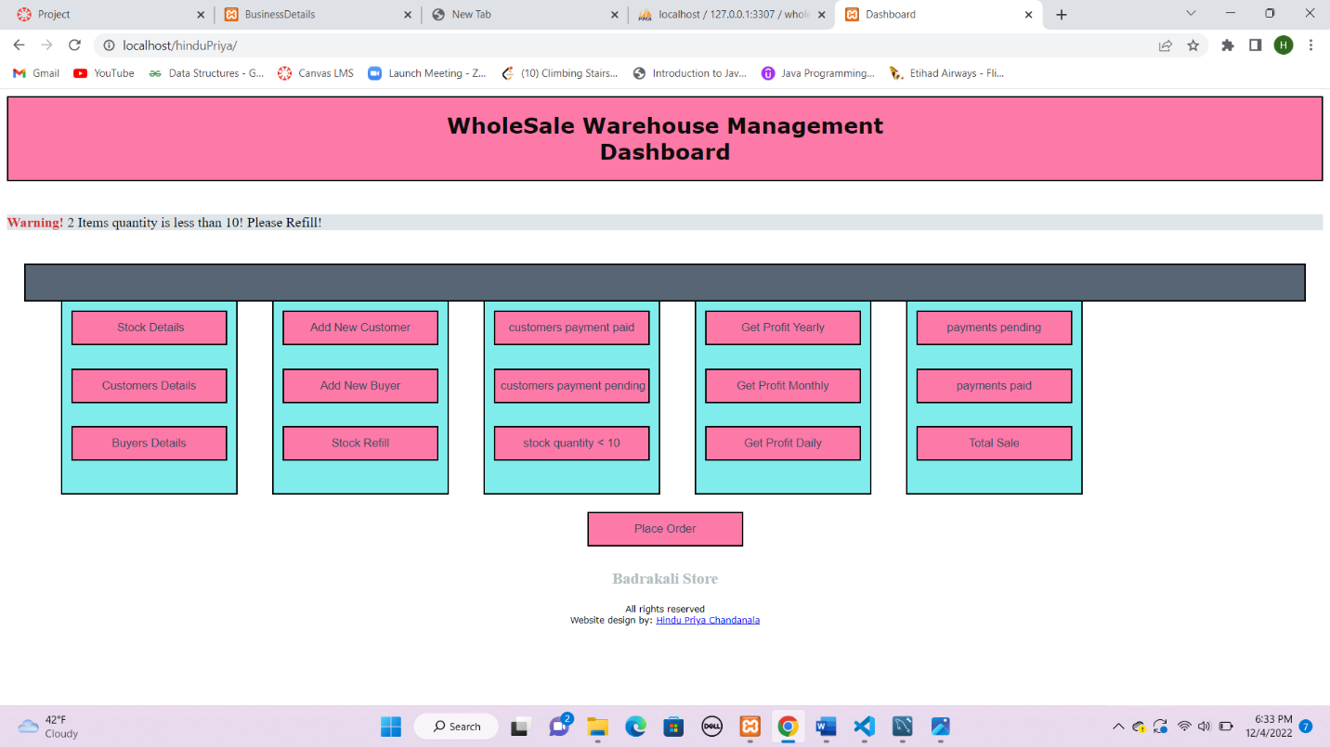

1. **List of queries (you can copy and paste the SQL code from MySQL)**

select * from stockdetails where quantity<10 (To develop warning and also shows the stock whose quantity < 10)

select * from stockdetails (Displays all stock information)

select * from customersdetails (Displays all Customers information)

select * from buyersdetails (Displays all Buyers information)

//list of payments pending

select * from orderdetails where paymentStatus='pending'

//list of payments paid

select * from orderdetails where paymentStatus='paid'

//list of total payments or Sales

select * from orderdetails

//To calculate profit daily

  $sql = "select orderID, count(*) as itemsSold from orderdetails where paymentStatus='paid' and year(DateOfOrder)=$year and month(dateOfOrder)=$month and day(dateOfOrder) = $date group by orderID";

$Query_ToJoin = "select x.StockID as stockId, x.Name as stockName, x.profit*x1.itemsSold as profit from (select s.StockID, s.Name, s.SellingPrice-b.buyingPrice as profit from stockdetails s inner join buyersdetails b on s.StockID=b.StockID) x inner join ($sql) x1 on x1.orderID=x.StockID";

//To calculate profit monthly

  $sql = "select orderID, count(*) as itemsSold from orderdetails where paymentStatus='paid' and year(DateOfOrder)=$year and month(dateOfOrder)=$month group by orderID";

$Query_ToJoin = "select x.StockID as stockId, x.Name as stockName, x.profit*x1.itemsSold as profit from (select s.StockID, s.Name, s.SellingPrice-b.buyingPrice as profit from stockdetails s inner join buyersdetails b on s.StockID=b.StockID) x inner join ($sql) x1 on x1.orderID=x.StockID";

//To calculate profit yearly

  $sql = "select orderID, count(*) as itemsSold from orderdetails where paymentStatus='paid' and year(DateOfOrder)=$year group by orderID";

$Query_ToJoin = "select x.StockID as stockId, x.Name as stockName, x.profit*x1.itemsSold as profit from (select s.StockID, s.Name, s.SellingPrice-b.buyingPrice as profit from stockdetails s inner join buyersdetails b on s.StockID=b.StockID) x inner join ($sql) x1 on x1.orderID=x.StockID";

//warning

  $sql = "select X.CustomerID,X.Name,X.Address,X.TelephoneNumber from customersdetails X inner join orderdetails Y on X.CustomerID=Y.CustomerID where Y.paymentStatus = 'pending' and X.CustomerID=$Customer_ID";

 $sql1 = "select * from customersdetails where CustomerID = $Customer_ID";

  $sql3 = "select quantity from stockdetails where StockID = $Stockid and quantity > $quantity";

   $sql4 = "SELECT DeliveryTime FROM buyersdetails where StockID = $Stockid";

    $sql1 = "select quantity from stockdetails where StockID=$stockId";

        $sql = "update stockdetails set quantity= $quantity where StockID=$stockId";

        $ins_Query = "insert into orderdetails values ($stockId,$Customer_ID, $quan,'$status','$date')";

//To refill stock

  $sql1 = "UPDATE stockdetails SET Quantity = $quantity, SellingPrice = $sp where  StockID =  $stockId" ;

//To add new stock

  $sql = "select * from stockdetails";

 $sql1 = "insert into stockdetails values($stockId,'$Name',$quantity,$sp)";

//To add new buyer

  $sql = "select * from buyersdetails";

  $sql1 = "insert into buyersdetails values($buyer_Id,'$buyer_name','$buyer_address',$productid,$PriceFromBuyer,$delivery_Time)";

//To add new customer

  $sql = "select * from customersdetails";

  $sql1 = "insert into customersdetails values('$name','$address','$telephone_no','$customerId')";

//List of customers paid

  $sql = "select distinct X.CustomerID,X.Name,X.Address,X.TelephoneNumber from customersdetails X inner join orderdetails Y on X.CustomerID=Y.customerID where y.paymentStatus = 'paid'";

//list of customers pending

  $sql = "select distinct c.CustomerID,c.Name,c.Address,c.TelephoneNumber from customersdetails c inner join orderdetails o on c.CustomerID=o.CustomerID where o.paymentStatus = 'pending'";

1. **Print screen of the interface used to enter a new detail of stock like their id, name, quantity. Include 20 items in your DB**

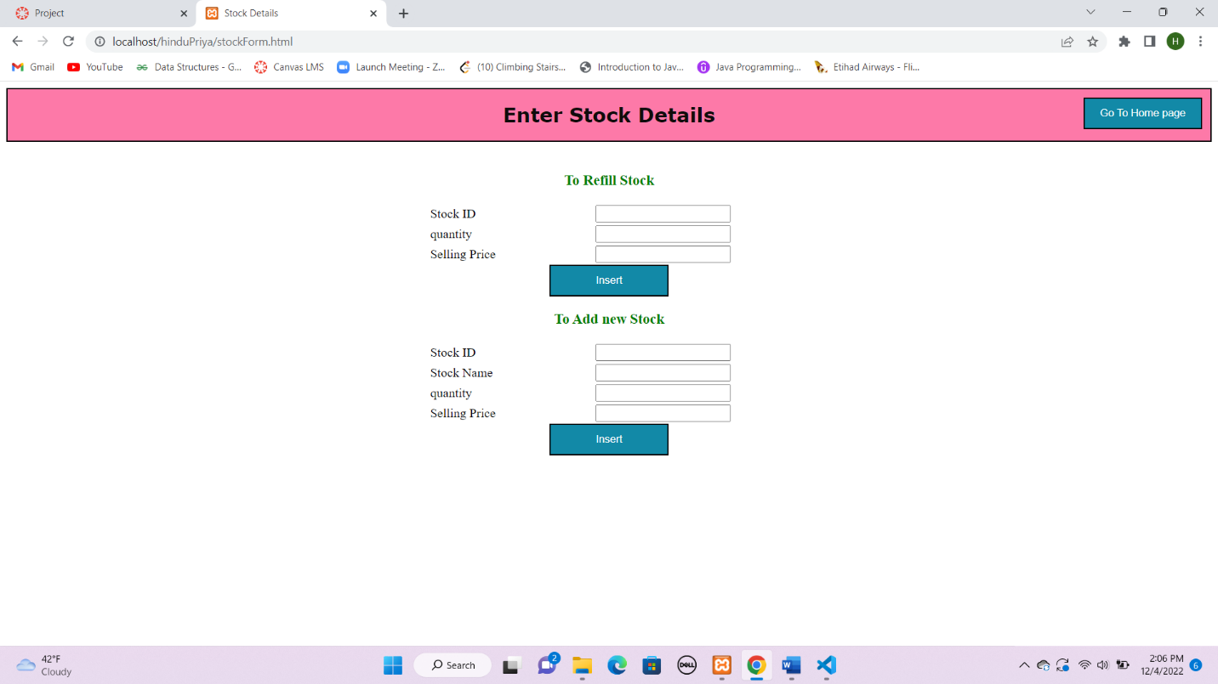

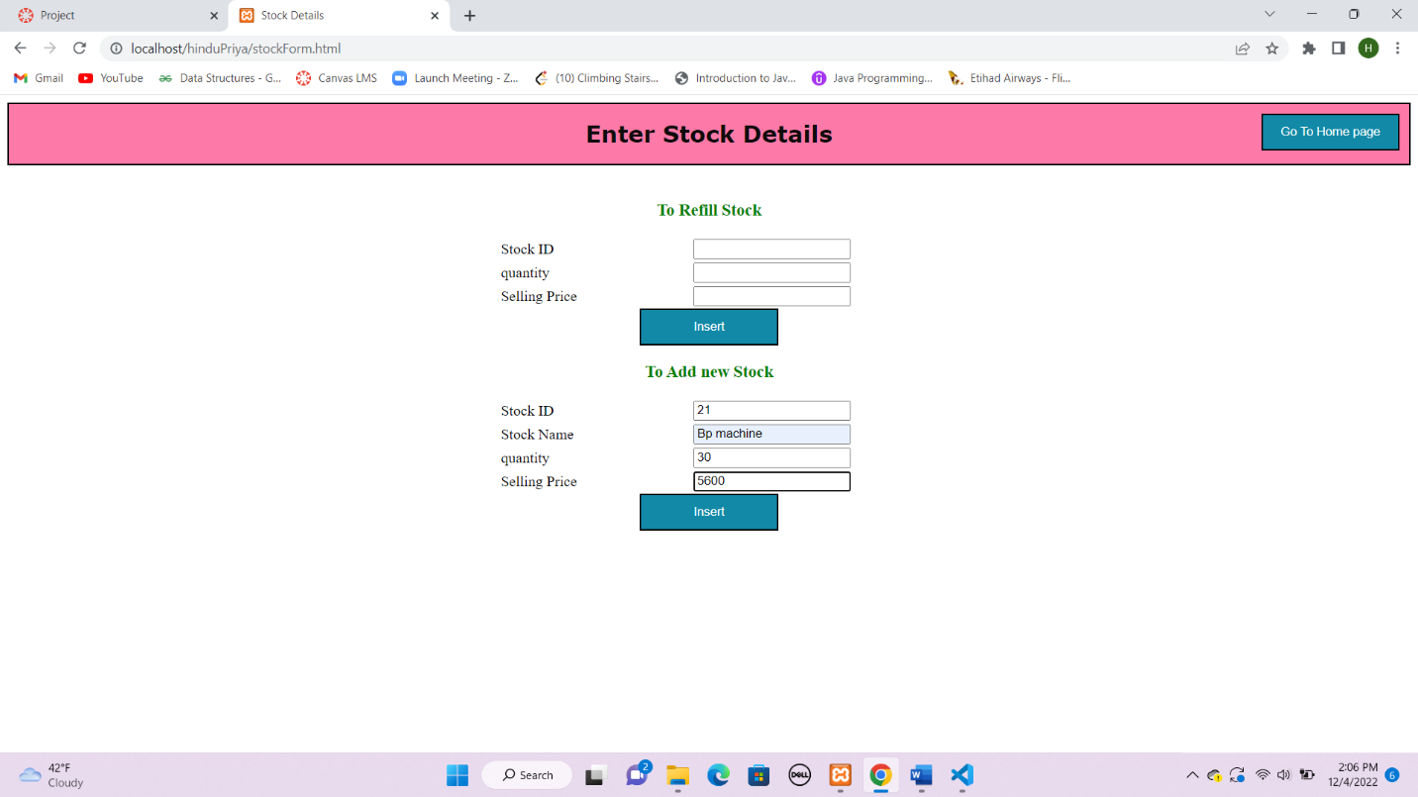

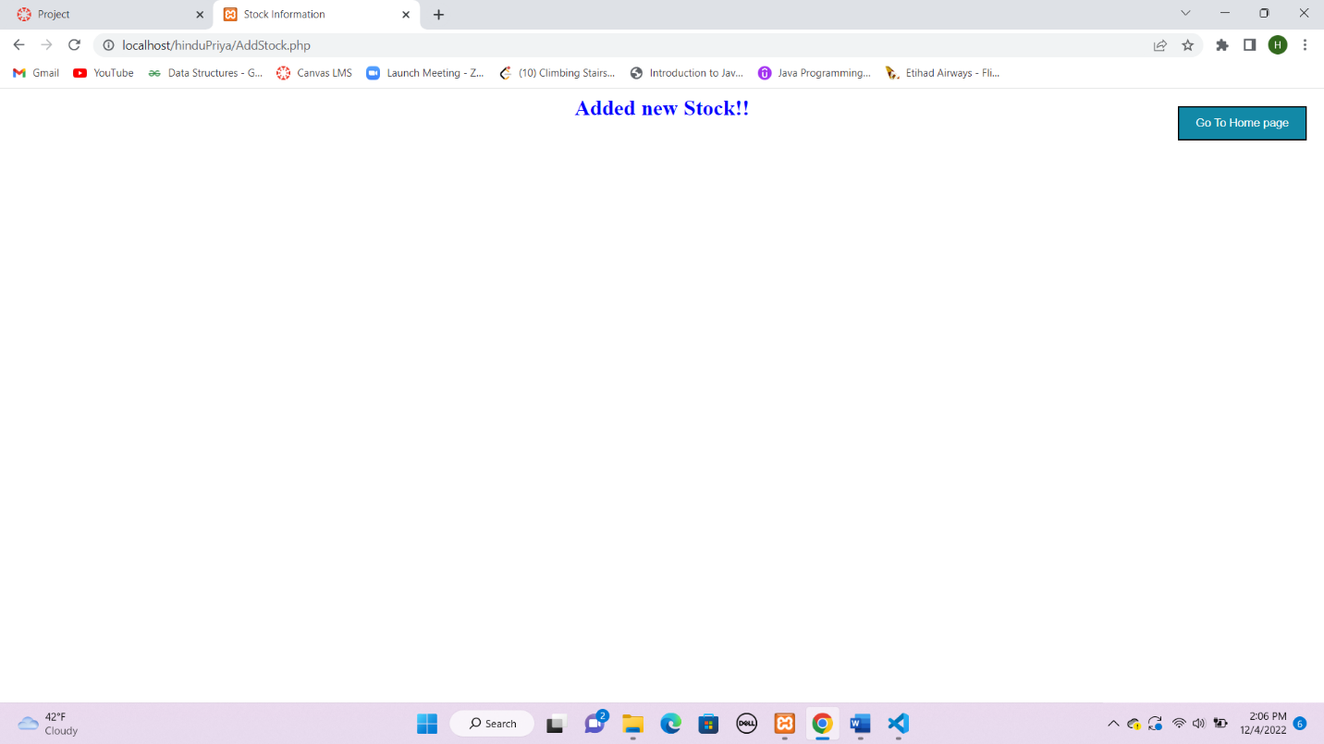

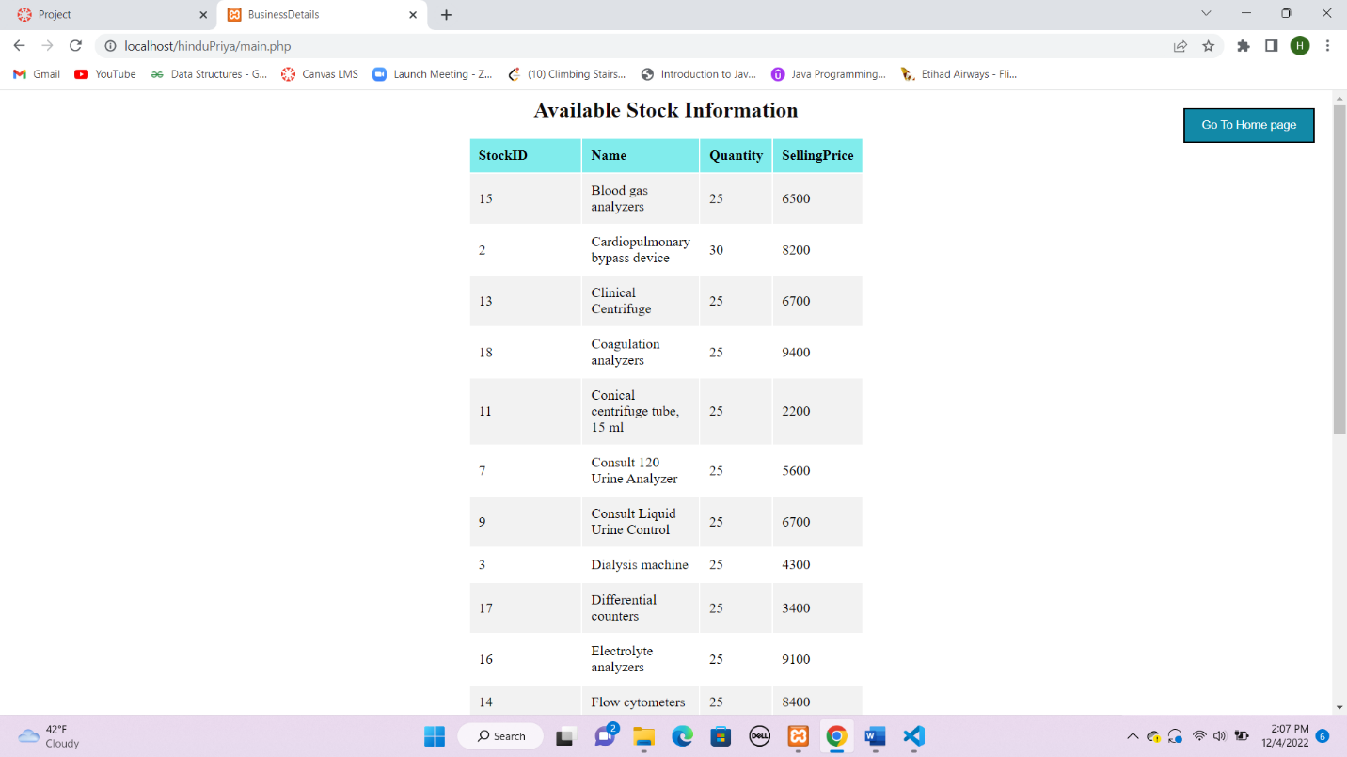

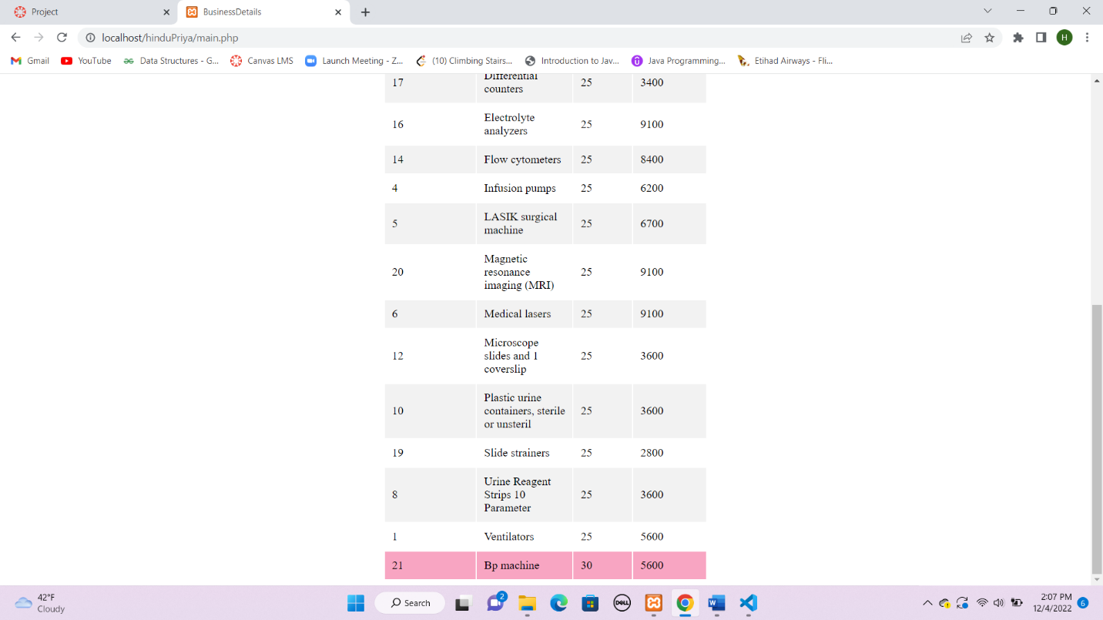

1. **Print screen of the interface used to enter the details of buyers from which the manager has to buy the stock like buyer id, name, address, stock id to be bought. Include 20 names in your DB**

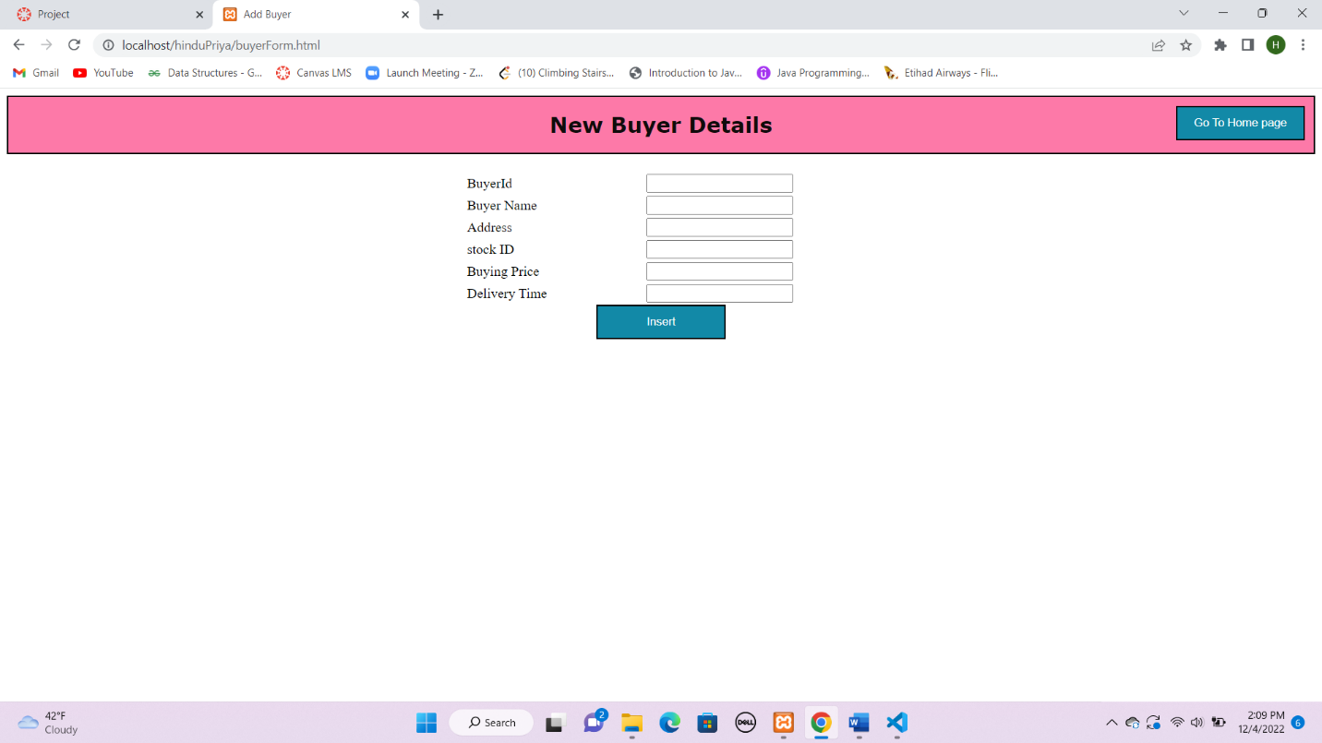

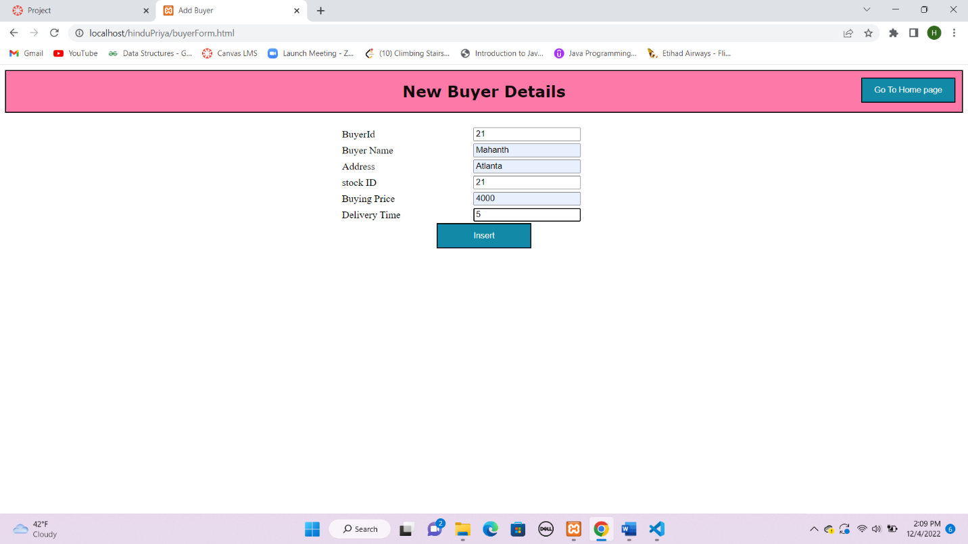

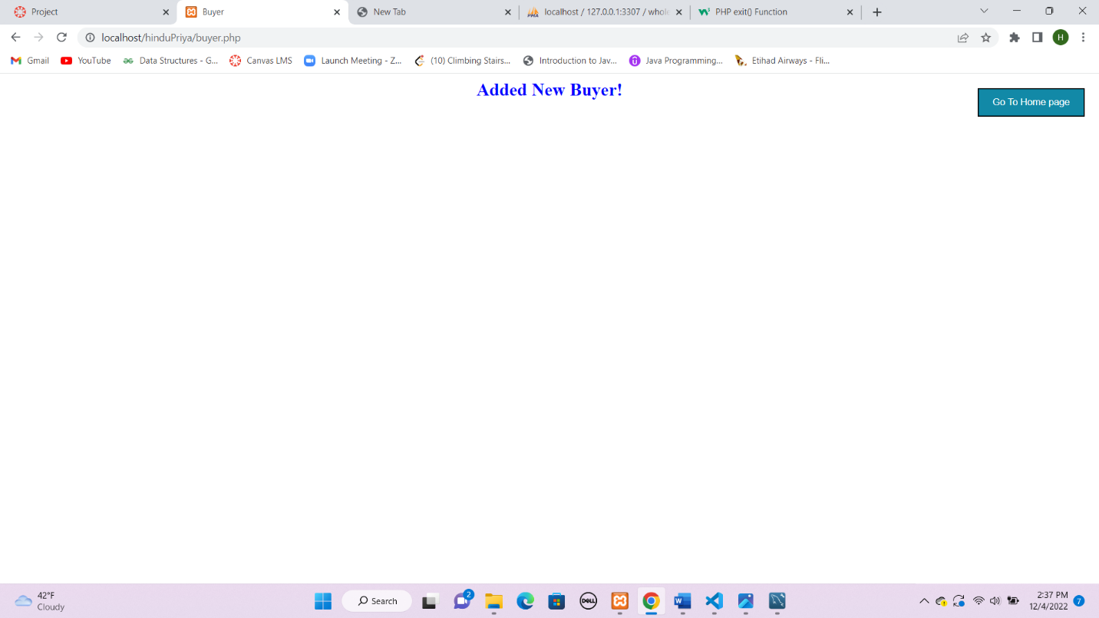

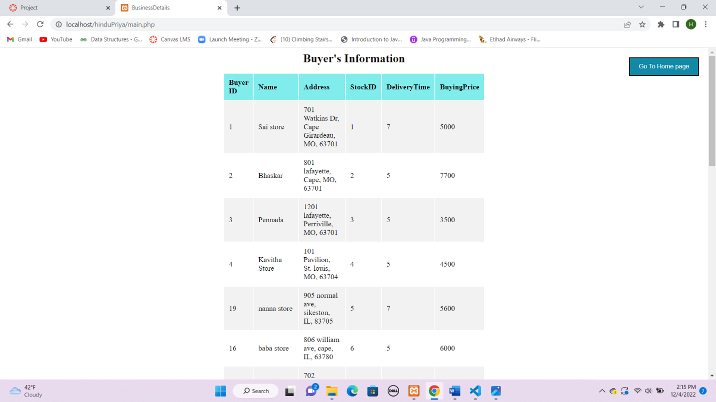

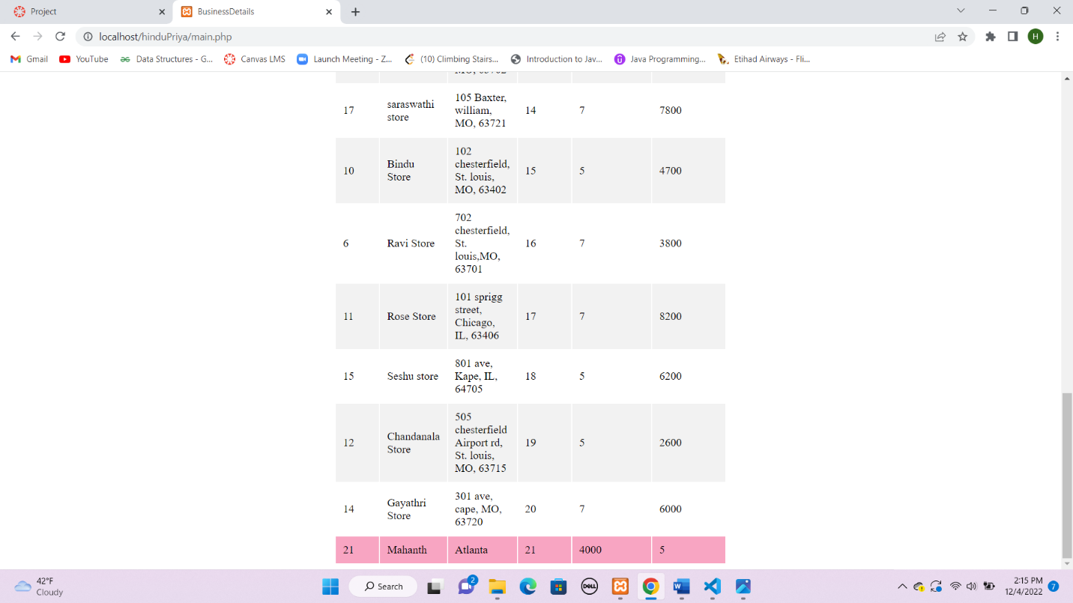

1. **Print screen of the interface used to enter the details of customers name, address, telephone number, id. Include 30 names in your DB**

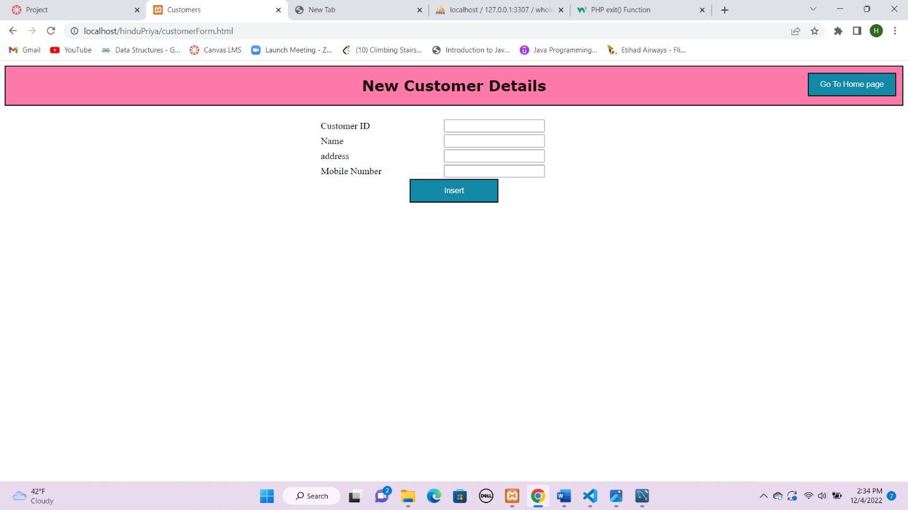

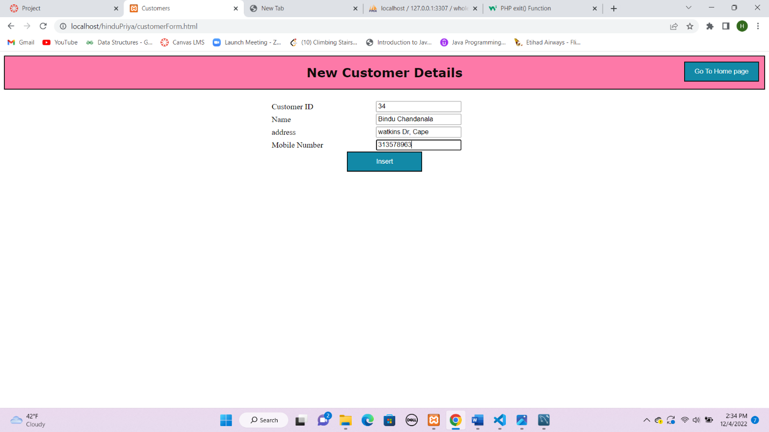

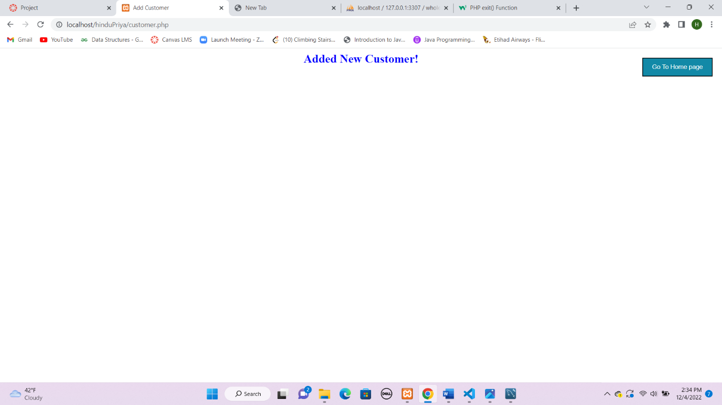

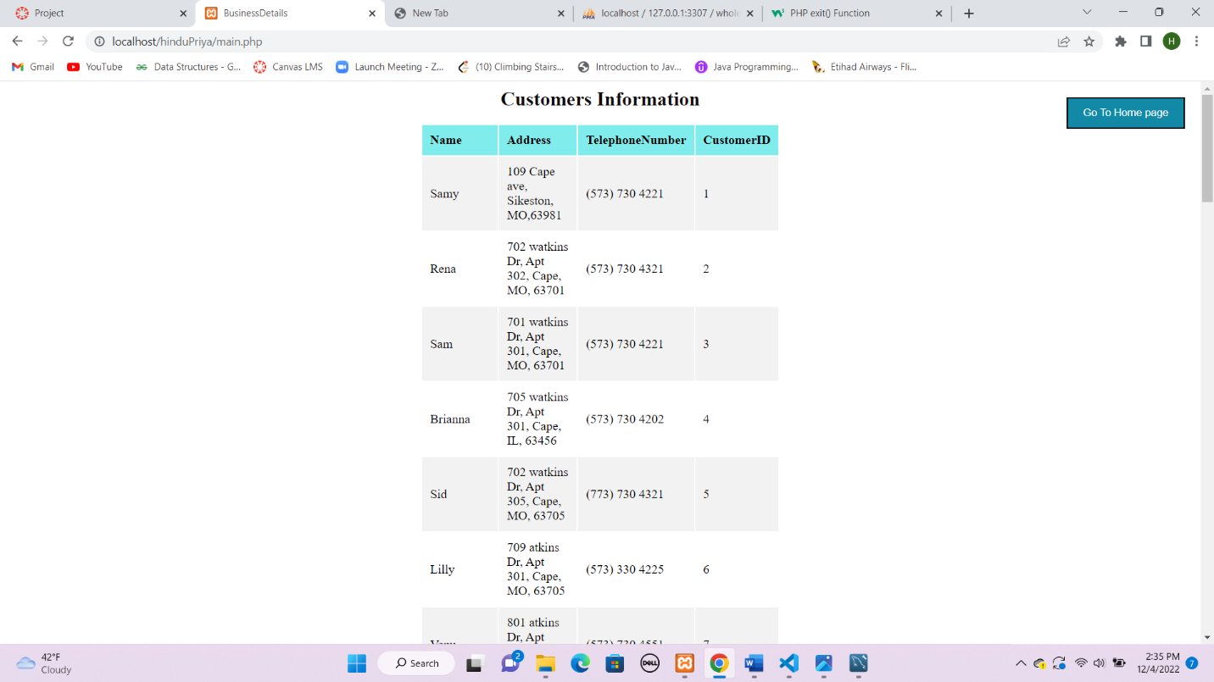

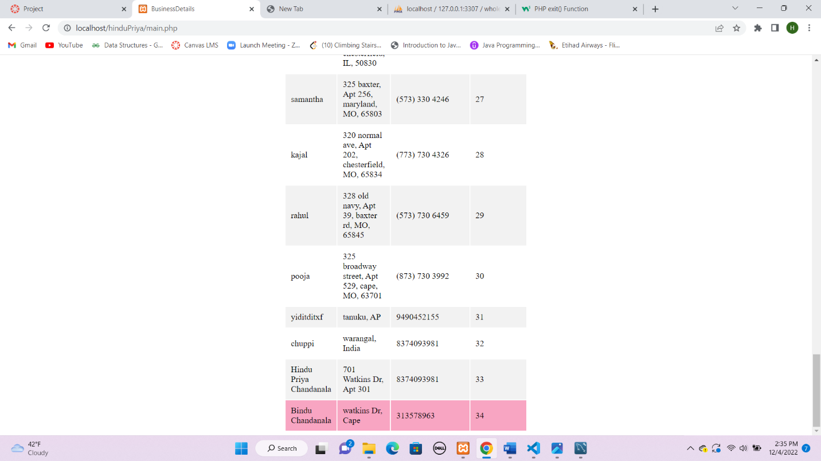

1. **Print screen of the MySQL table attributes Maintaining the details of stock like their id, name, quantity. Include 20 items in your DB**

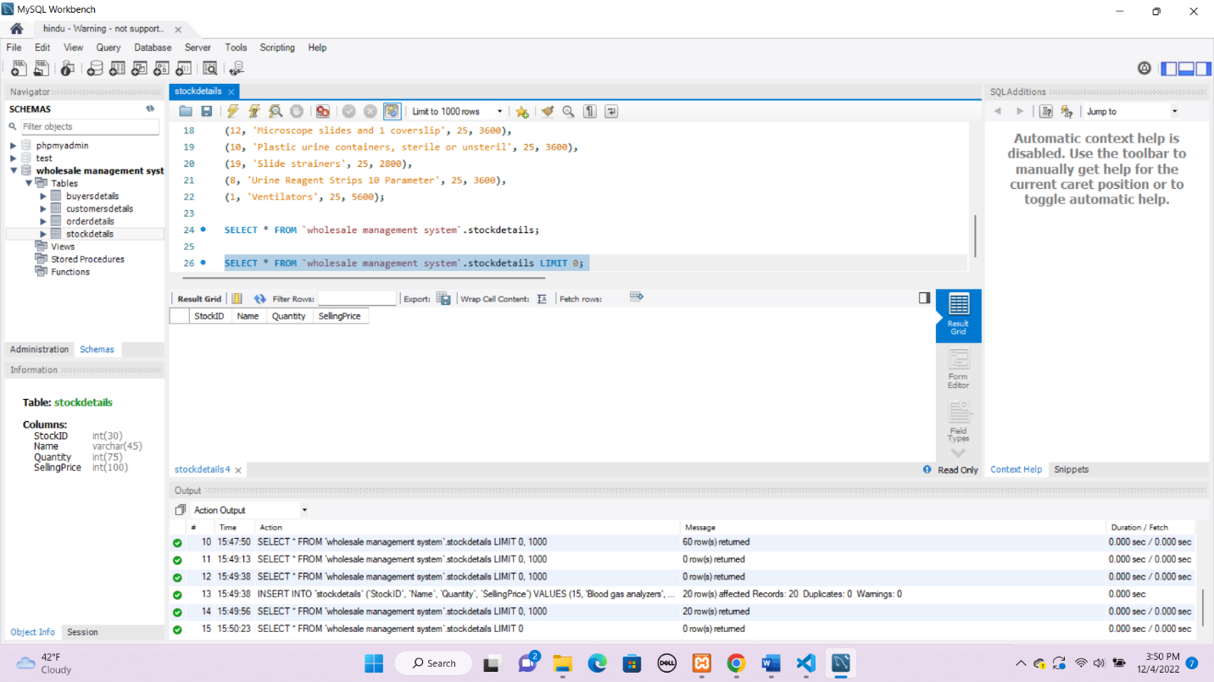

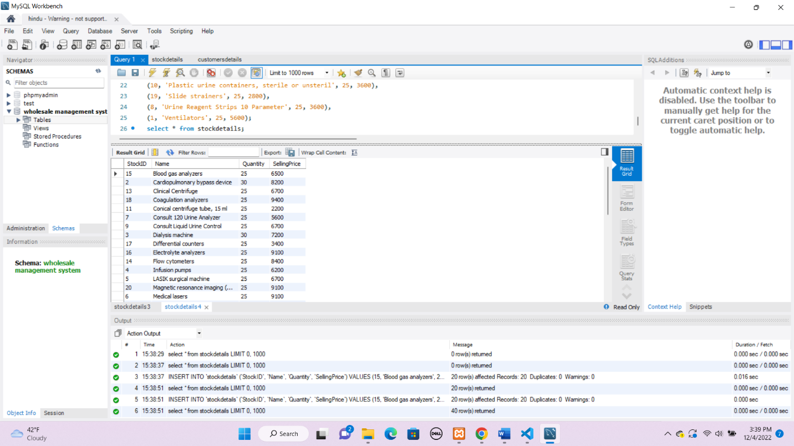

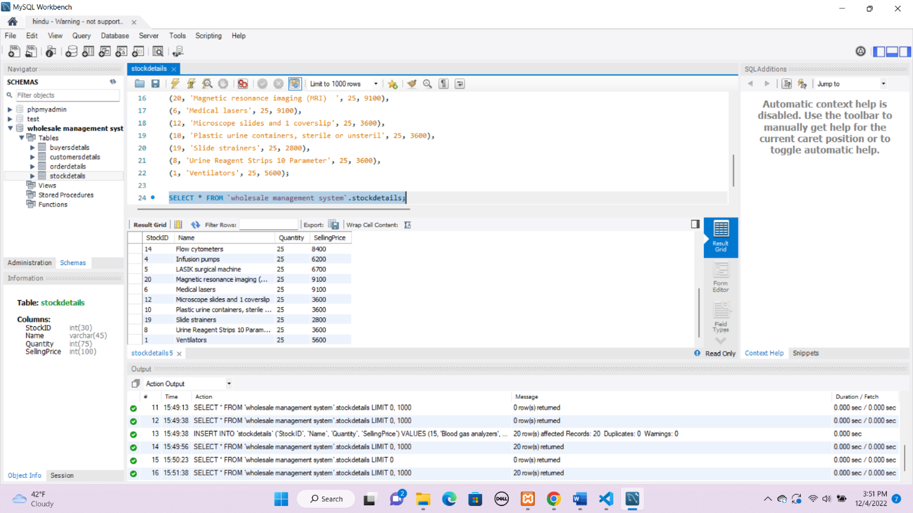

1. **Print screen of the MySQL table attributes Maintaining the details of buyers from which the manager has to buy the stock like buyer id, name, address, stock id to be bought. Include 20 names in your DB**

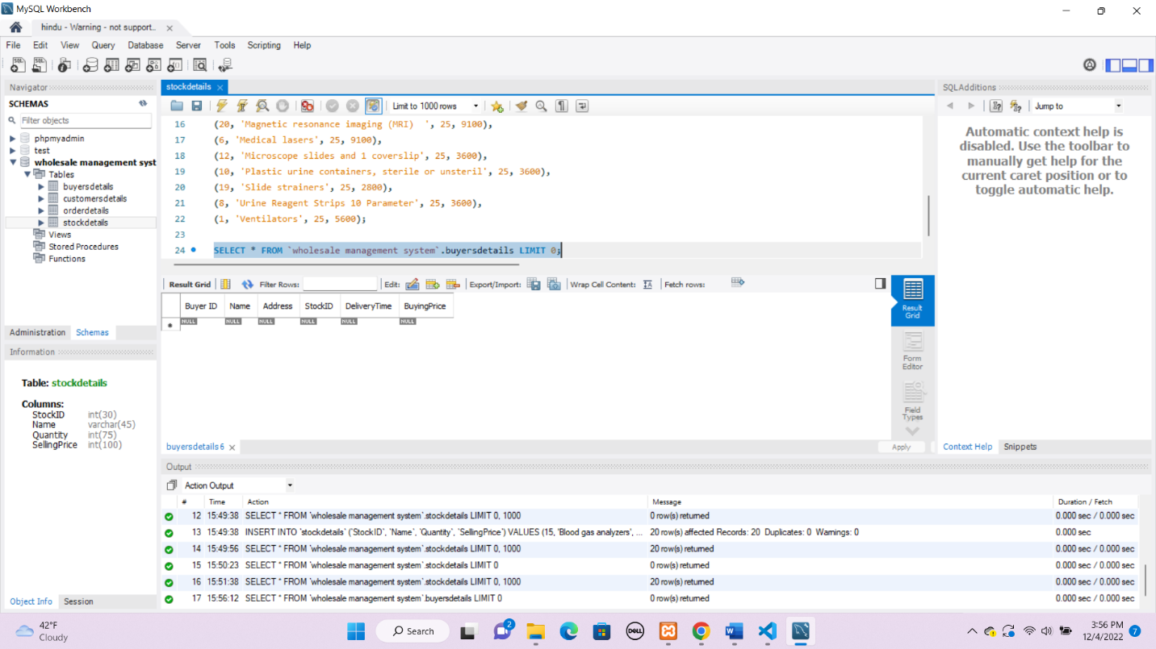

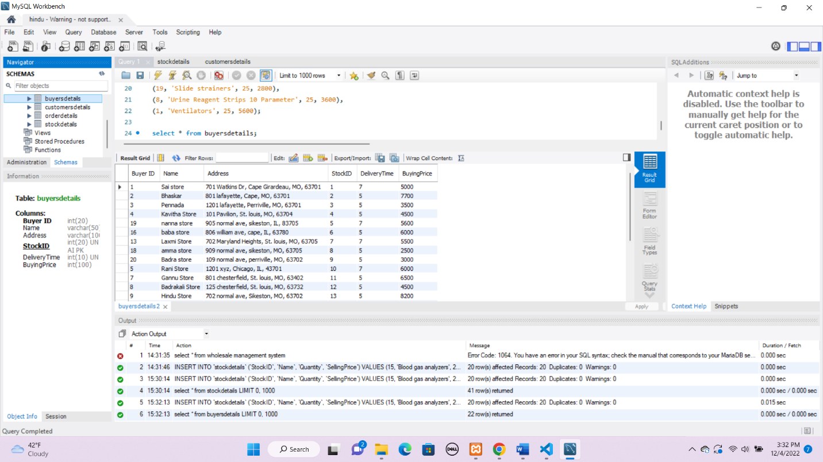

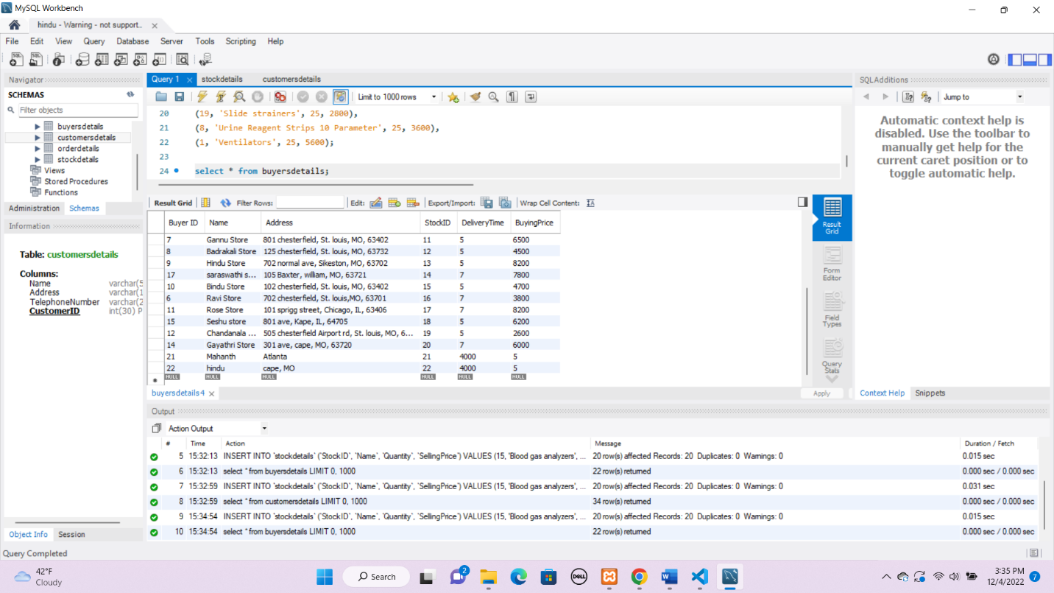

1. **Print screen of the MySQL table attributes Maintaining the details of customers name, address, telephone number, id. Include 30 names in your DB**

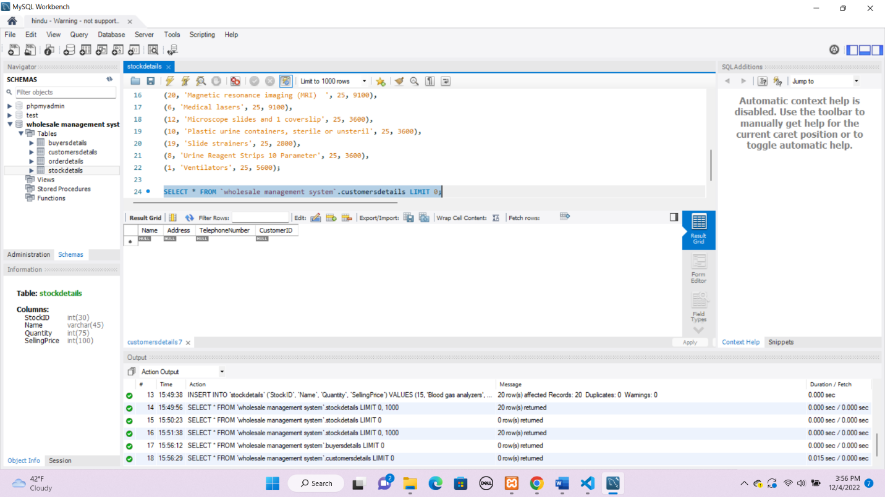

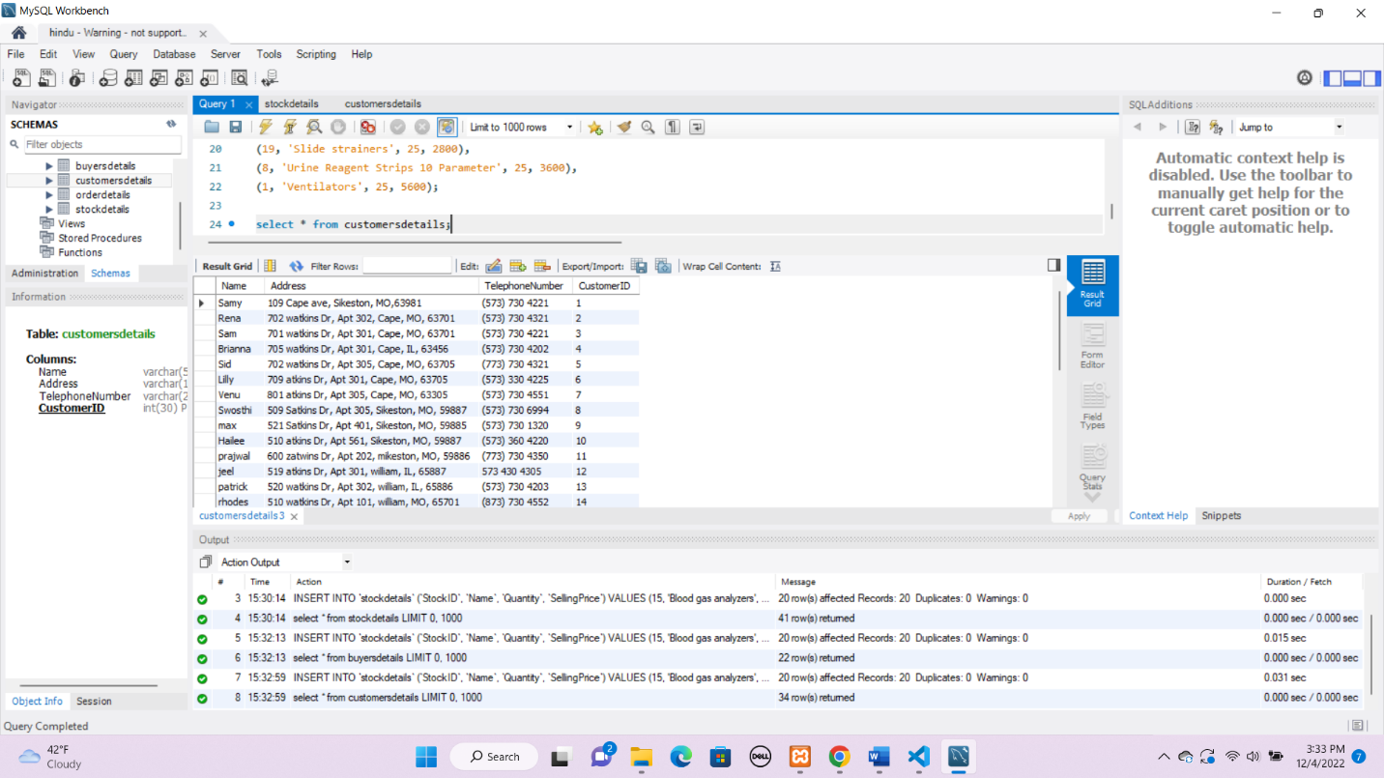

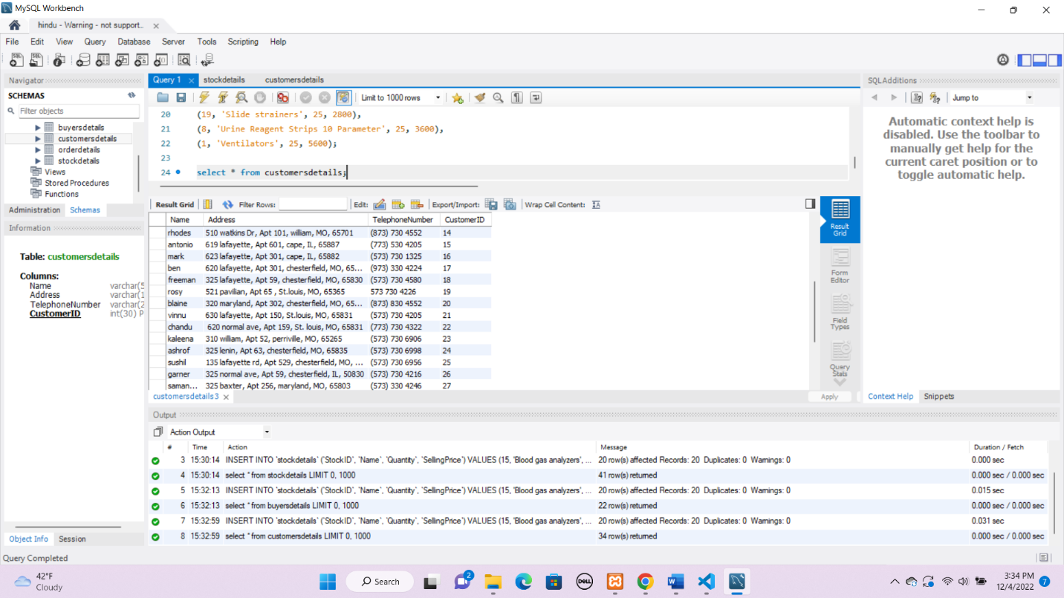

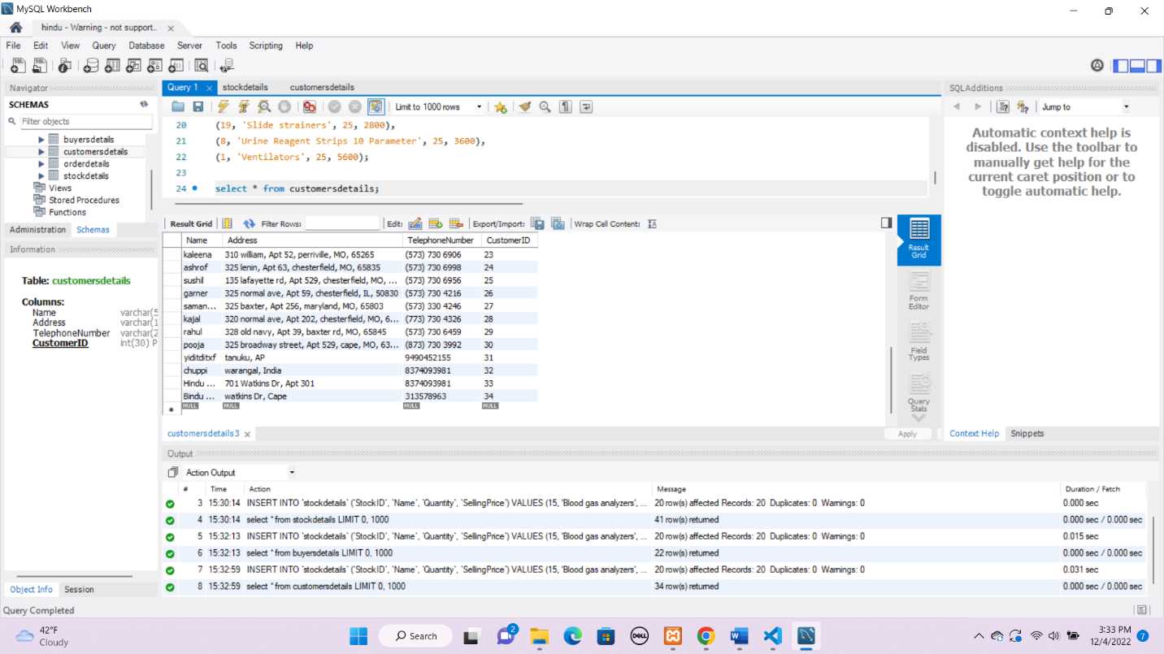

1. **Print screen of the MySQL table content Maintaining the details of stock like their id, name, quantity. Include 20 items in your DB**

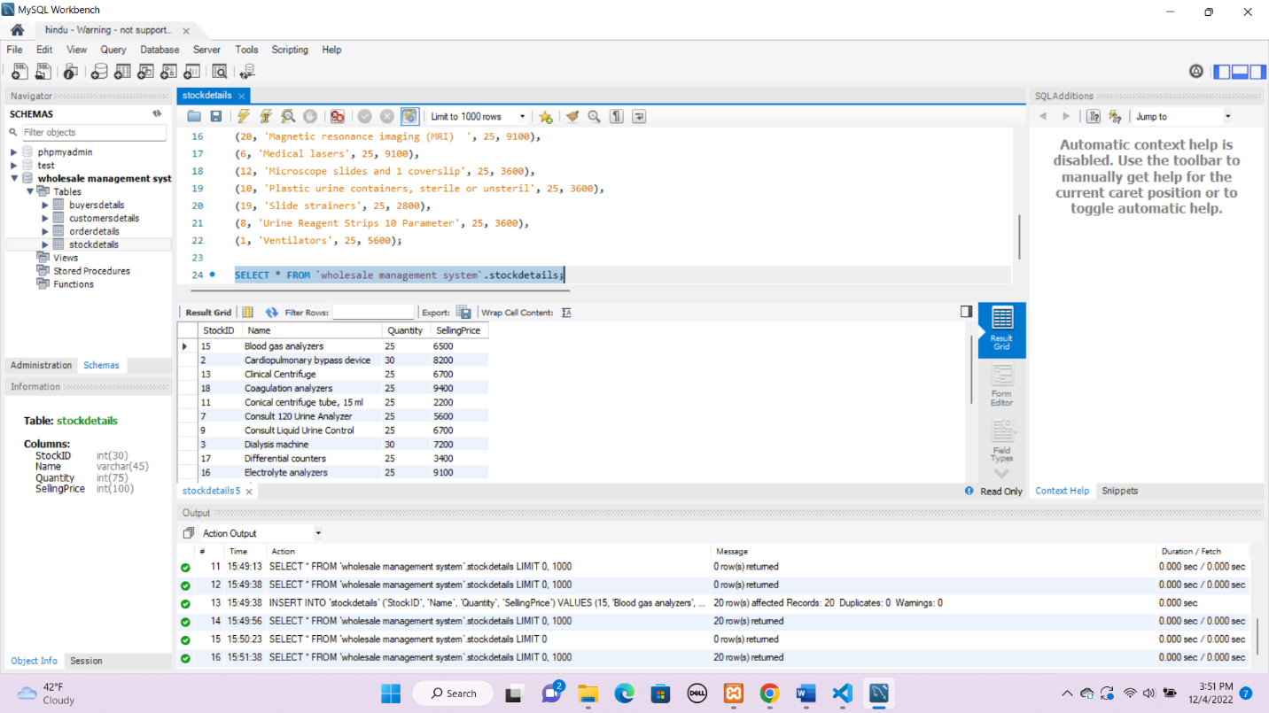



1. **Print screen of the MySQL table content Maintaining the details of buyers from which the manager has to buy the stock like buyer id, name, address, stock id to be bought. Include 20 names in your DB**





1. **Print screen of the MySQL table content Maintaining the details of customers name, address, telephone number, id. Include 30 names in your DB**







1. **Prints screen of a report via a user-friendly interface/window with the Defaulter’s list of customers who have not paid their pending amount.**

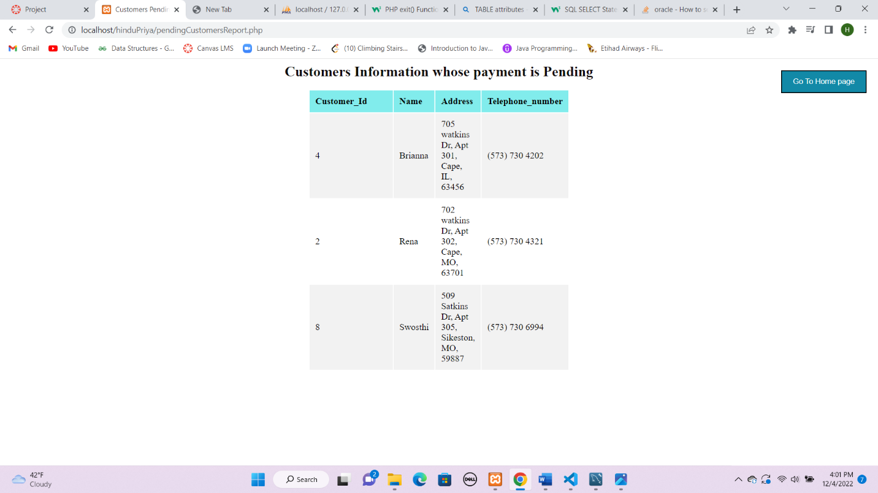

1. **Prints screen of a report via a user-friendly interface/window with the List of payments paid**

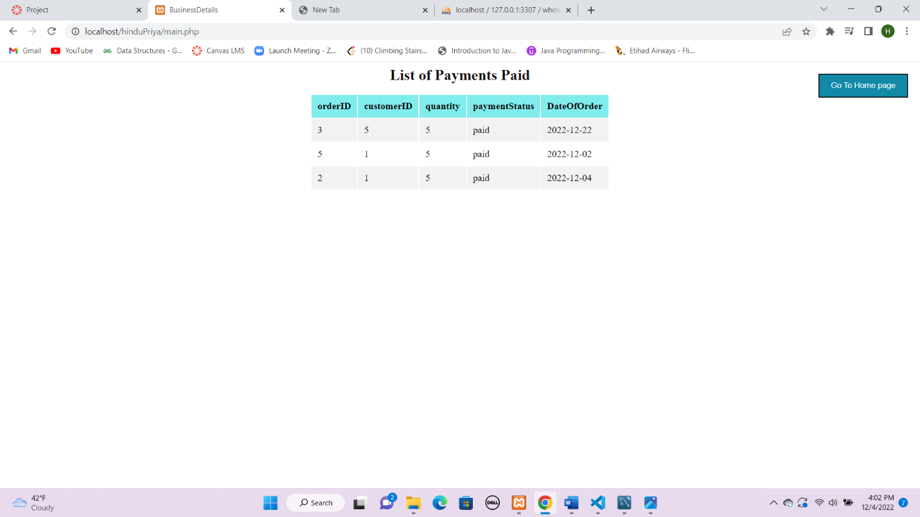

1. **Print screen of a report via a user-friendly interface/window with the List of payments pending.**

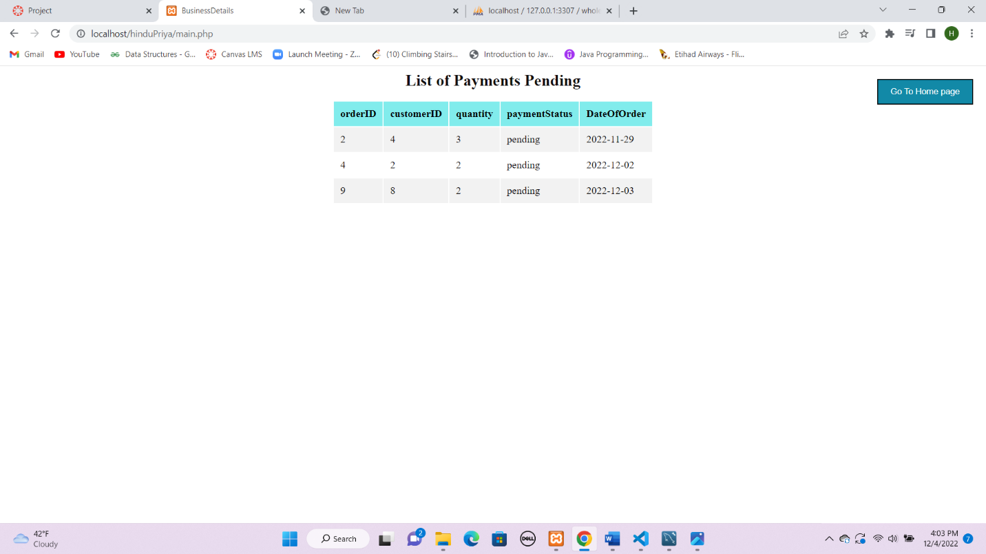

1. **Prints screen of a report via a user-friendly interface/window with the List of the stock that is to buy if quantity goes less than a particular amount (10 items).**

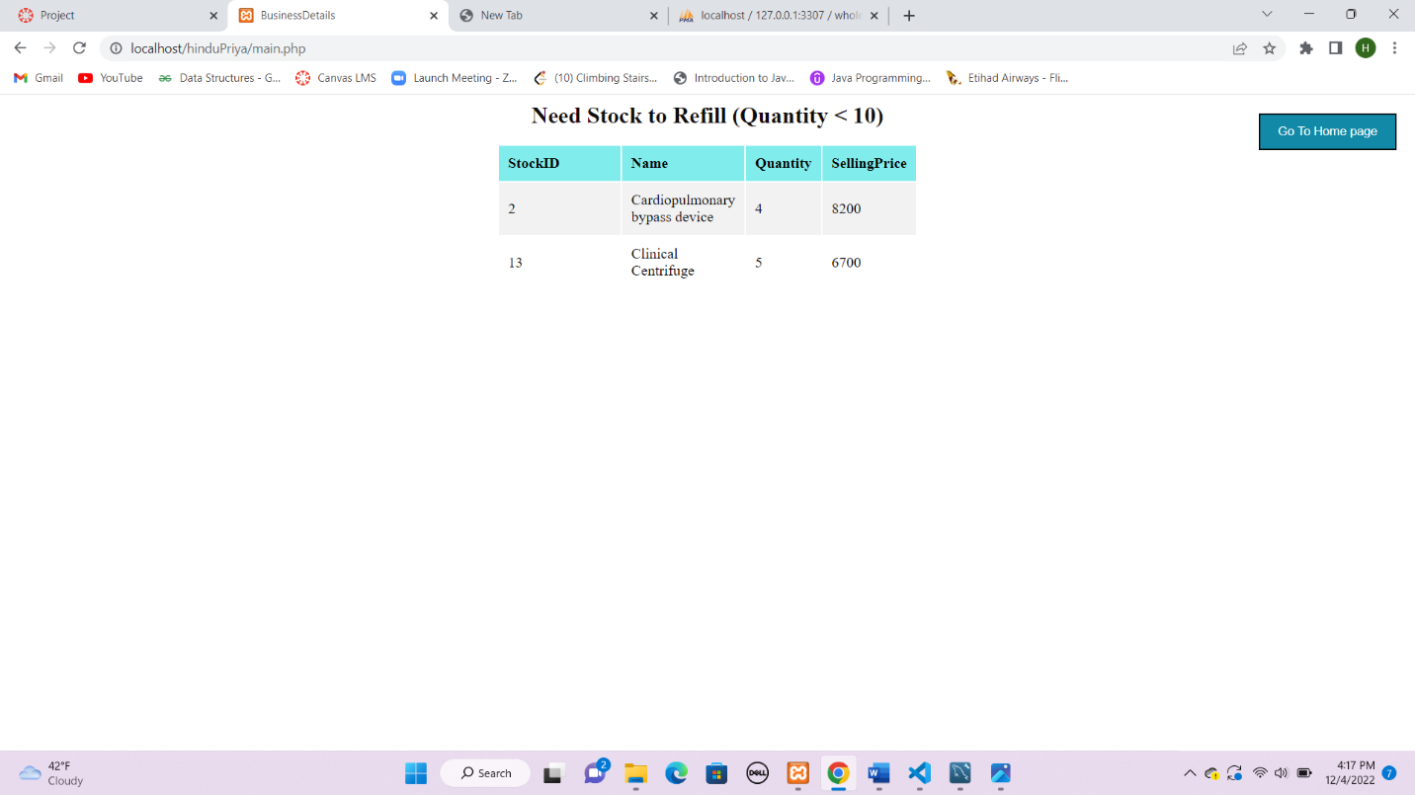

1. **Print screen of a report via a user-friendly interface/window with the Profit calculation for a month.**

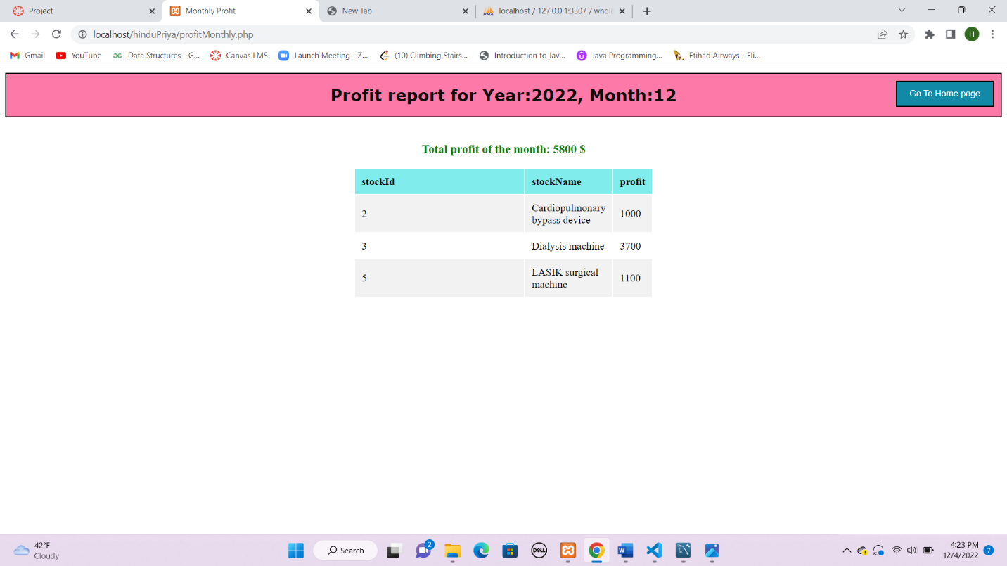

1. **Print screen of the Produced warning when an error occurs if the Quantity cannot be sold to a customer if the required amount is not present in stock and the date of delivery should be maintained up to which stock can be provided.**

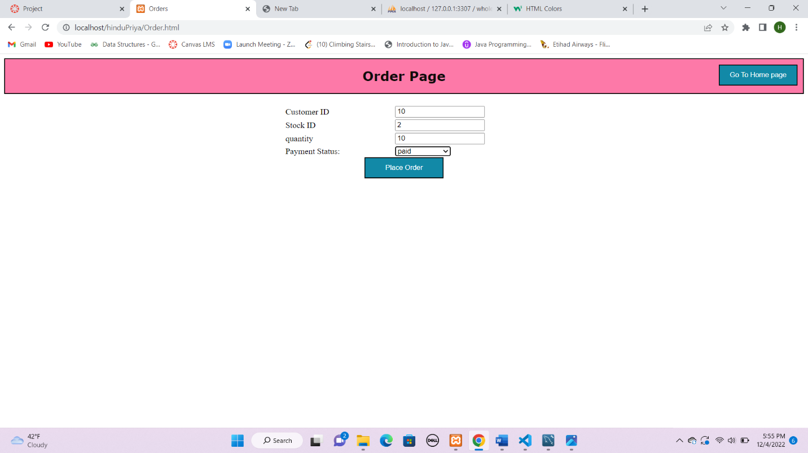

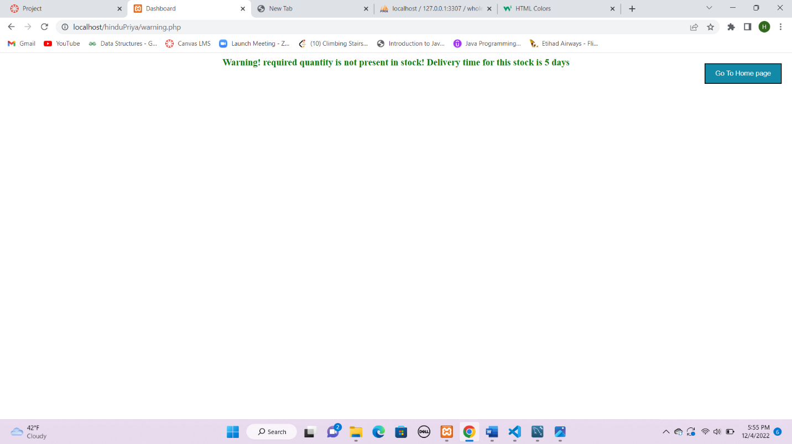

Stock ID 2 is shown in Stock Refill (Quantity < 10). That’s why dashboard throws a warning.

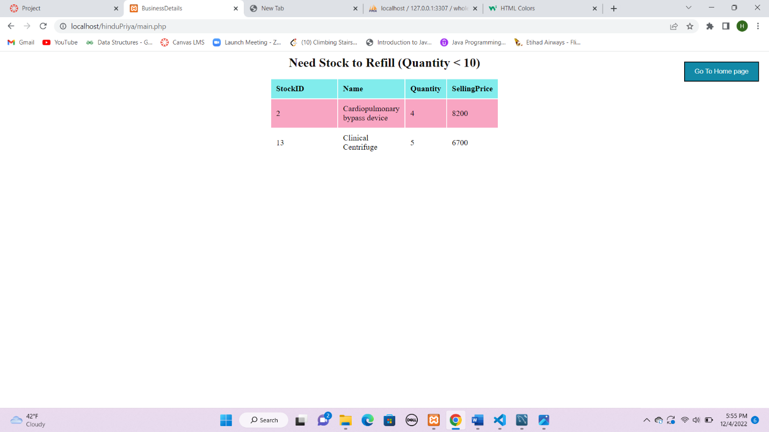

1. **Print screen of the Produced warning when a customer who have not paid their pending amount is requesting more items.**

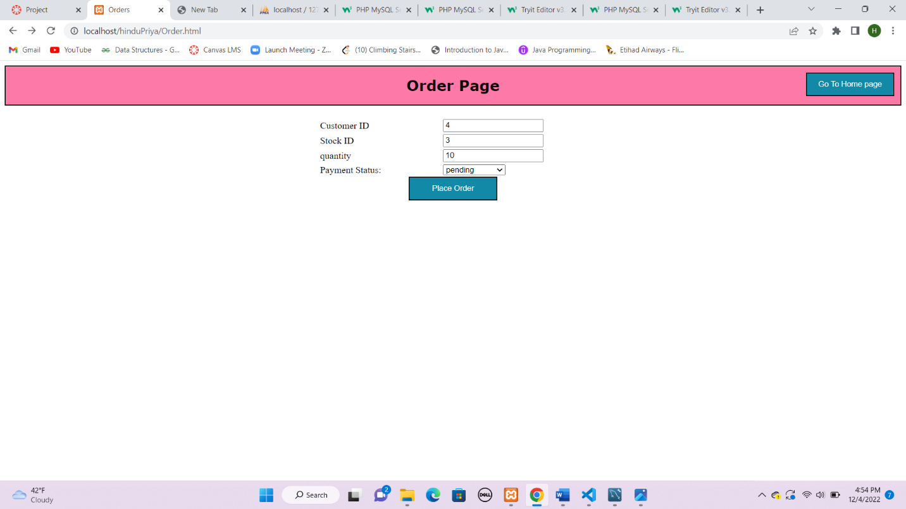

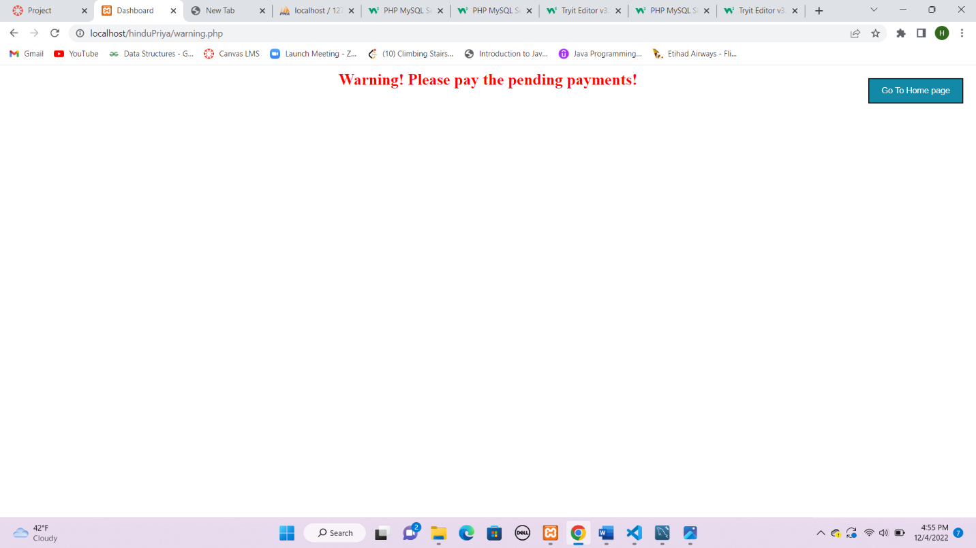

Below Screenshot provides data about Customer Id 4 requesting for more items is listed in pending payments

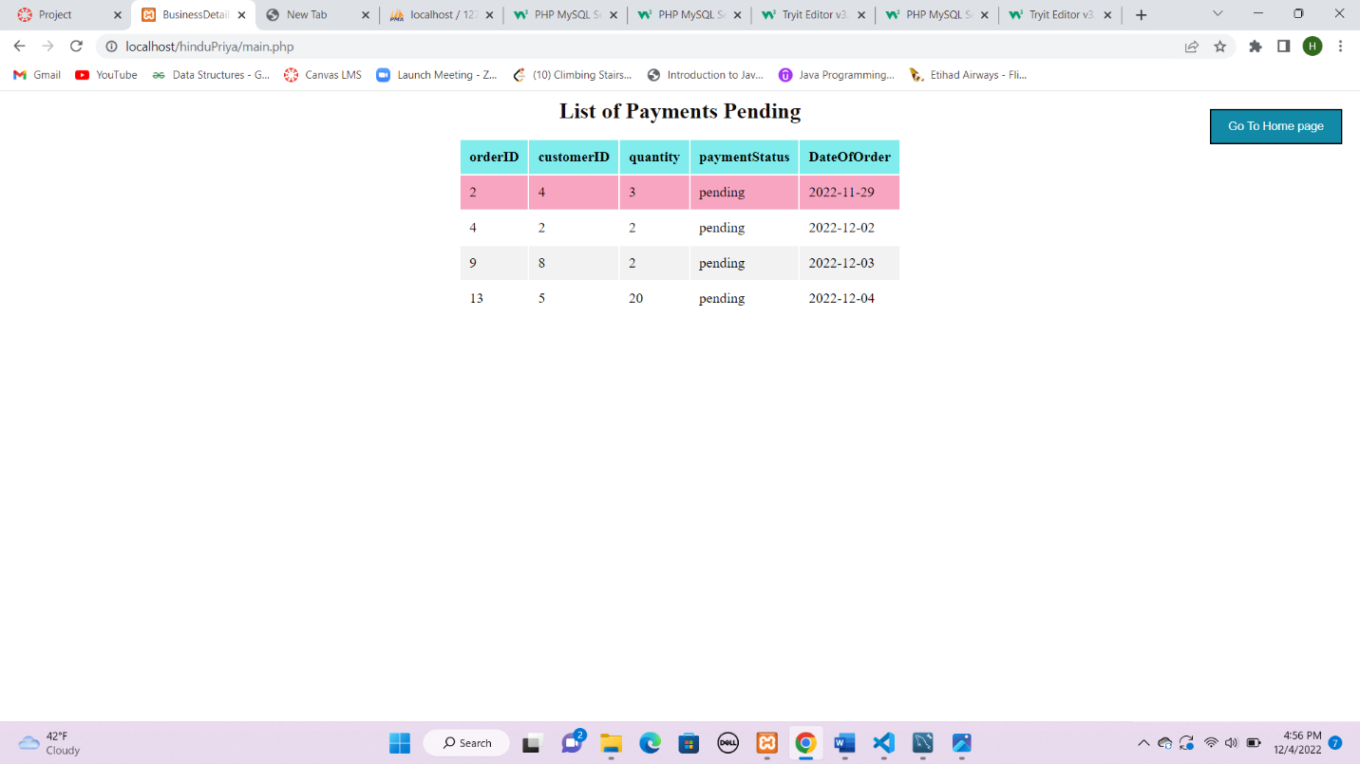

1. **Print screen of the Produced warning when the quantity of an item goes less than a particular amount**

When quantity goes less than 10 items, dashboard throws warning about number of items running out of stock and it warns to refill. Here 2 items quantity is less than 10 .

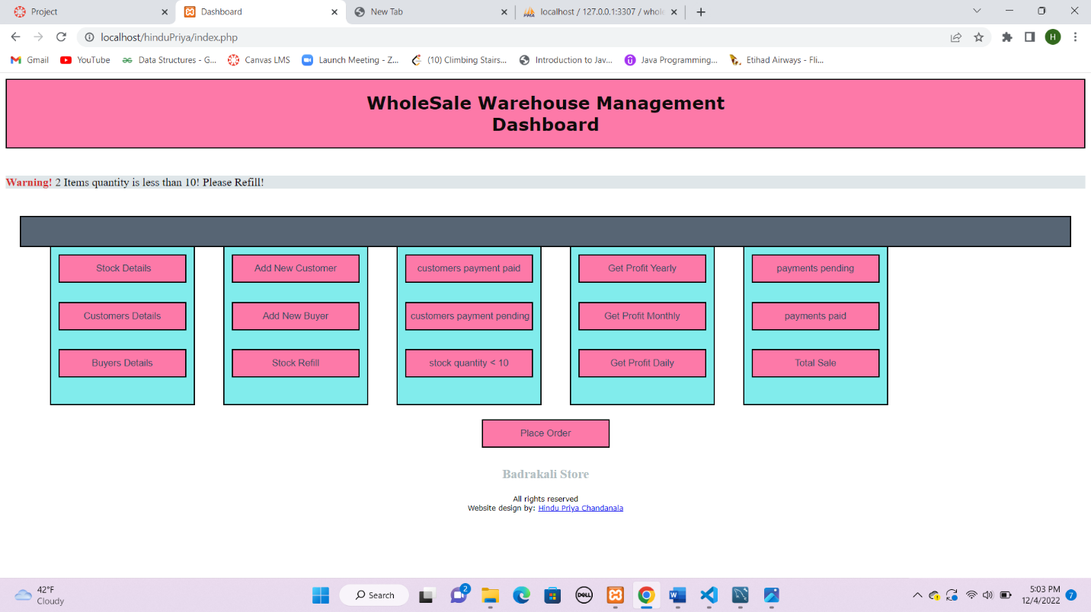

**Those 2 items can be seen when one clicks Stock quantity < 10 button.**

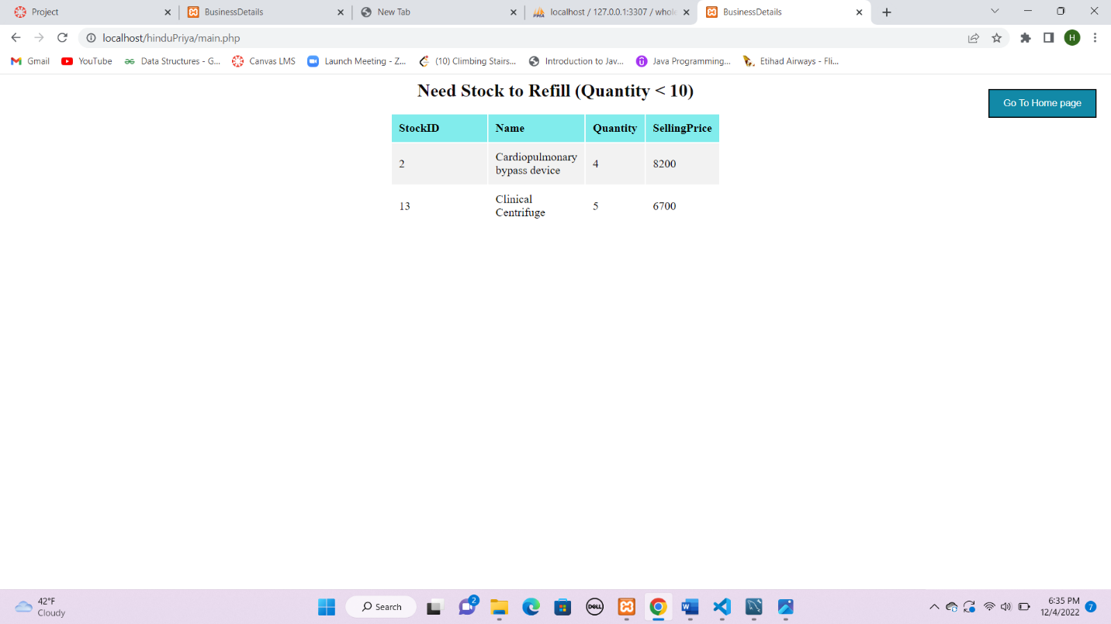

**One can refill the stock, using Stock Refill button: Here, I refilled 2 items as mentioned in the warning. Stock id 2 and 13.**

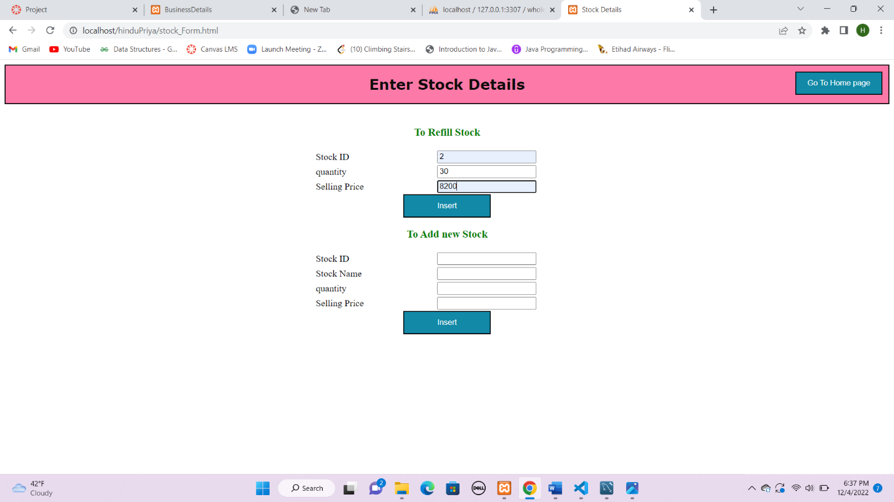

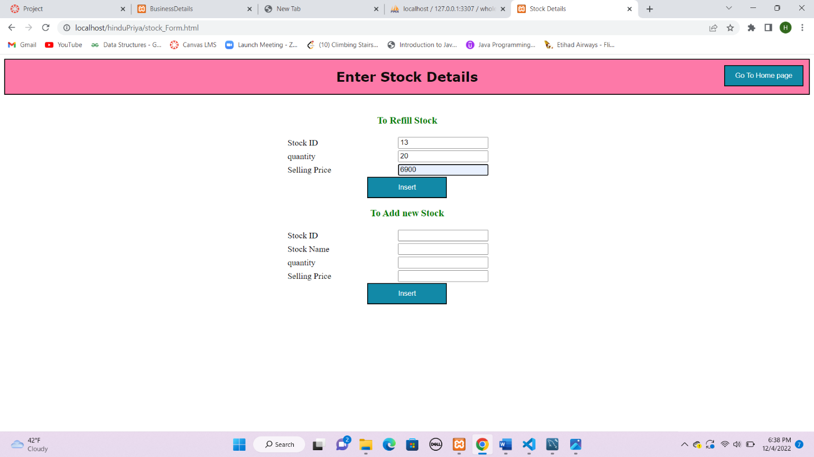

**Since I have refilled those 2 items now, warning bar goes away in the dashboard.**

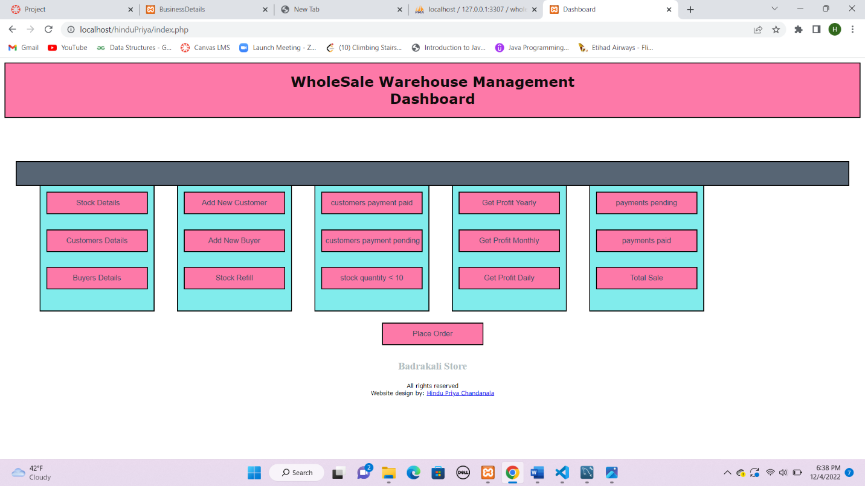

1. **Conclusion. Reflect on your experience completing this project as an individual. The good and the bad. The time spent. Anything new you learned on your own**

I have learnt a lot during doing this assignment. Now, I have good idea on PHP, MySQL, HTML and how to link database from MySQL to the PHP.

This project gave me holistic view of how any store or franchise like Walmart or any organizations which maintains the stock information, customers information, buyers’ information.

I have spent **7-9 days on this project** and its worth spending.

I have also made sure there is proper order of customer ID, Buyer Id are maintained. It really boosted up the confidence in me.

With interest, I have created buttons to calculate profit yearly, profit daily also. I learned PHP, HTML, javascript **on my own**.

Below are the screenshots provided to calculate them.

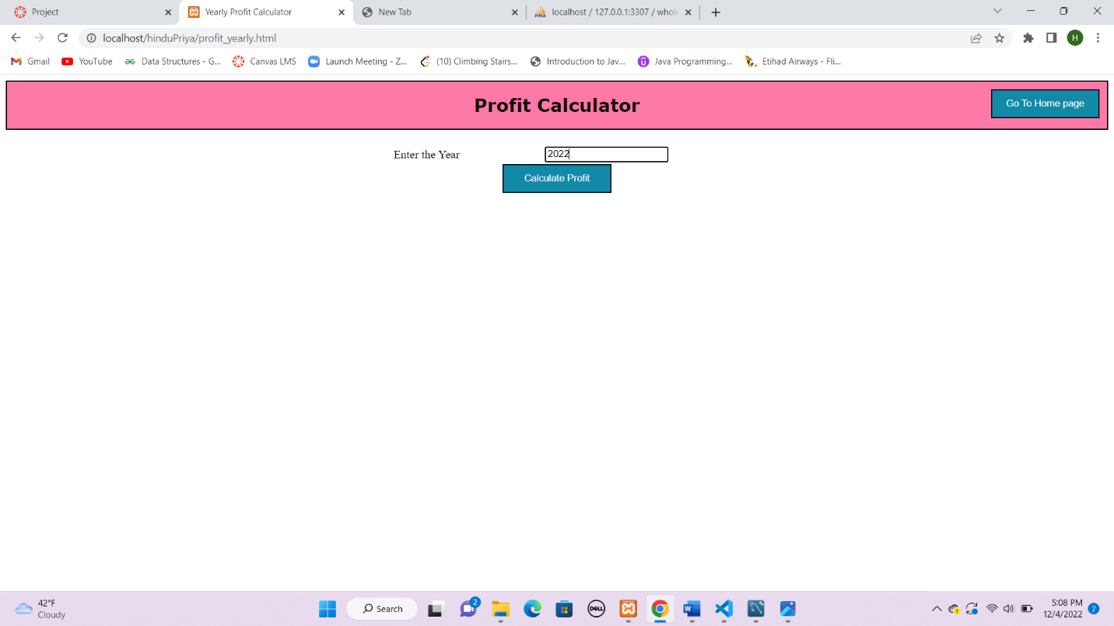

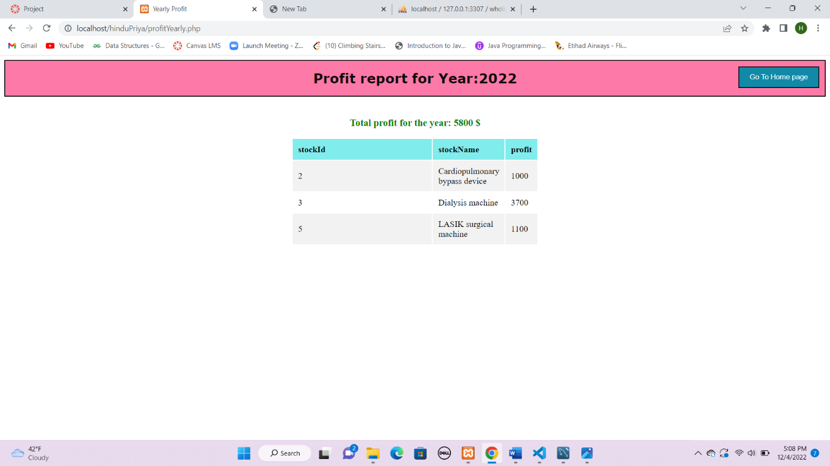

Profit daily:

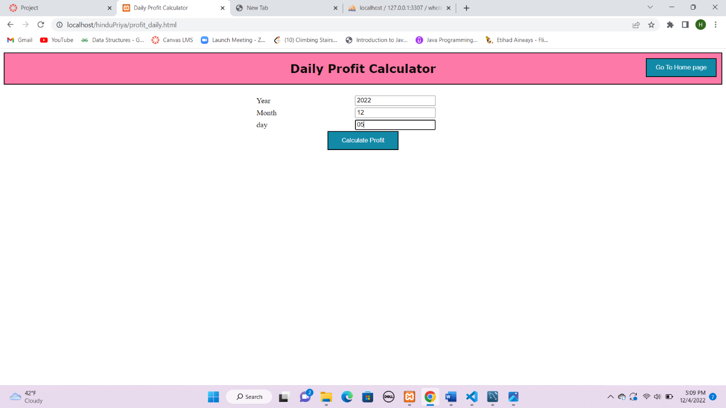

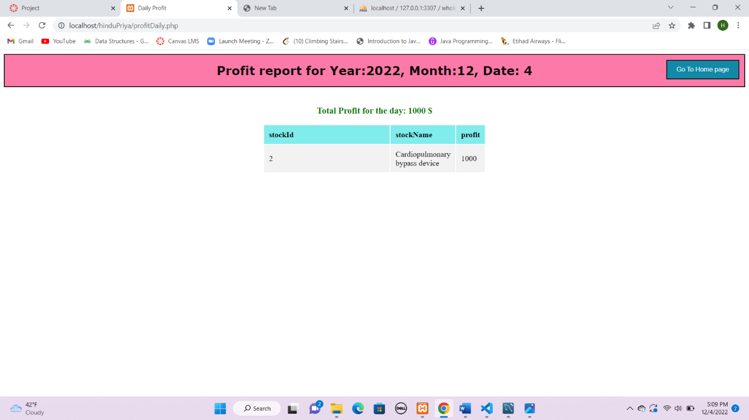

1. **copy of Java/PHP/language/etc. code you used to implement the GUI**

**index.php:**

<html>

<head>

    <title >

        Dashboard

    </title>

    <meta charset="utf-8">

    <meta name="viewport" content="width=device-width, initial-scale=1">

    <link rel = "stylesheet" type = "text/css" href = "styleSheet.css">

</head>

<body>

    <div class="main">

        <h1><b> WholeSale Warehouse Management <br> Dashboard</b></h1>

    </div>

    <br />

    </br>

    <?php

    $servername = "127.0.0.1:3307";

  $username = "root";

  $password = "";

  $database = "wholesale management system";

  $conn = new mysqli($servername, $username, $password, $database);

  if ($conn->connect_error) {

    die("Connection failed: " . $conn->connect_error);

  }

  $sql = "select * from stockdetails where quantity<10";

 $y = $conn->query($sql);

  $num =$y->num_rows;

  if($num>0){ ?>

    <div class="alert warning">

    <b id = "warn" >Warning!</b> <?php echo "$num Items quantity is less than 10! Please Refill!" ?>

  </div>

<?php

  }

    ?>

    <br />

    <div class = "body" >

    <div class="category">

        <form action="main.php" method="post">

            <input type="hidden" name="query" value="select * from stockdetails">

            <input type="hidden" name="header" value="Available Stock Information">

            <input id="details" type="submit" value=" Stock Details" class="button1" >

        </form>

        <form action="main.php" method="post">

            <input type="hidden" name="query" value="select * from customersdetails">

            <input type="hidden" name="header" value="Customers Information">

            <input id="details" type="submit" value="Customers Details" class="button1" >

        </form>

        <form action="main.php" method="post">

            <input type="hidden" name="query" value="select * from buyersdetails">

            <input type="hidden" name="header" value="Buyer's Information">

            <input id="details" type="submit" value="Buyers Details" class="button1" >

        </form>

        </div>

        <div class="category">

        <form action="customer_Form.html" method="post">

            <input id="details" type="submit" value="Add New Customer" class="button1" >

        </form>

        <form action="buyer_Form.html" method="post">

            <input id="details" type="submit" value="Add New Buyer" class="button1" >

        </form>

<form action="stock_Form.html" method="post">

    <input id="details" type="submit" value="Stock Refill" class="button1" >

</form>

      </div>

        <div class="category">

        <form action="paidCustomersReport.php" method="post">

            <input id="details" type="submit" value="customers payment paid" class="button1" >

        </form>

        <form action="pendingCustomersReport.php" method="post">

            <input id="details" type="submit" value="customers payment pending" class="button1" >

        </form>

        <form action="main.php" method="post">

            <input type="hidden" name="query" value="select * from stockdetails where quantity<10">

            <input type="hidden" name="header" value="Need Stock to Refill (Quantity < 10)">

            <input id="details" type="submit" value="stock quantity < 10" class="button1" >

        </form>

        </div>

        <div class="category">

        <form action="profit_yearly.html" method="post">

            <input type="hidden" name="query" value="">

            <input type="hidden" name="header" value="Profit">

            <input type="hidden" name="func" value="year">

            <input id="details" type="submit" value="Get Profit Yearly" class="button1" >

        </form>

        <form action="profit_monthly.html" method="post">

            <input type="hidden" name="query" value="">

            <input type="hidden" name="header" value="Profit">

            <input type="hidden" name="func" value="month">

            <input id="details"type="submit" value="Get Profit Monthly" class="button1" >

        </form>

        <form action="profit_daily.html" method="post">

            <input type="hidden" name="query" value="">

            <input type="hidden" name="header" value="Profit">

            <input type="hidden" name="func" value="daily">

            <input id="details" type="submit" value="Get Profit Daily" class="button1" >

        </form>

        </div>

        <div class="category">

        <form action="main.php" method="post">

            <input type="hidden" name="query" value="select * from orderdetails where paymentStatus='pending'">

            <input class = "main" type="hidden" name="header" value="List of Payments Pending" >

            <input id="details" type="submit" value="payments pending" class="button1" >

        </form>

        <form action="main.php" method="post">

            <input type="hidden" name="query" value="select * from orderdetails where paymentStatus='paid'">

            <input class = "main" type="hidden" name="header" value="List of Payments Paid" >

            <input id="details" type="submit" value="payments paid" class="button1" >

        </form>

        <form action="main.php" method="post">

            <input type="hidden" name="query" value="select * from orderdetails ">

            <input type="hidden" name="header" value="Total Sale" class = "main">

            <input id="details" type="submit" value="Total Sale" class="button1" >

        </form>

</div>

</div>

        <div class="order">

        <form action="Order.html" method="post">

            <input id="details" type="submit" value="Place Order" class="button1" >

        </form>

    </div>

</body>

<?php include 'footer.php'?>

</html>

**main.php:**

<html>

<head>

  <title> BusinessDetails</title>

  <meta charset="utf-8">

  <meta name="viewport" content="width=device-width, initial-scale=1">

  <link rel = "stylesheet" type = "text/css" href = "styleSheet.css">

</head>

<body>

  <b>

    <h1><?php

        echo $_POST['header'];

        ?></h1>

  </b>

  <?php

      $servername = "127.0.0.1:3307";

  $username = "root";

  $password = "";

  $database = "wholesale management system";

  $conn = new mysqli($servername, $username, $password, $database);

  if ($conn->connect_error) {

    die("Connection failed: " . $conn->connect_error);

  }

  $sql = $_POST['query'];

 $y = $conn->query($sql);

  $fieldinfo =$y->fetch_fields();

  $num =$y->num_rows; ?>

  <table class="tableWithBorder">

    <tr>

      <?php

      foreach ($fieldinfo as $val) { ?>

        <th>

          <?php

          echo $val->name;

          ?>

        </th>

      <?php } ?>

    </tr>

    <?php while ($row =$y->fetch_assoc()) { ?>

      <tr>

        <?php

        foreach ($fieldinfo as $val) { ?>

          <td>

            <?php

            echo $row[$val->name];

            ?>

          </td>

        <?php

} ?>

      </tr>

    <?php

} ?>

  </table>

  <form class="homepage" action="index.php" method="post">

    <input type="submit" value="Go To Home page" class="button">

  </form>

</body>

</html>

**warning.php:**

<html>

<head>

  <title>

    Dashboard</title>

  <meta charset="utf-8">

  <meta name="viewport" content="width=device-width, initial-scale=1">

  <link rel = "stylesheet" type = "text/css" href = "styleSheet.css">

  <script type="text/javascript">

    function successMessage() {

      var success = document.getElementById("xx")

      success.textContent = "Order has been placed!!"

      success.style.textAlign = "center"

      success.style.color = "blue"

    }

    </script>

    <script type="text/javascript">

    function errorMessage(x) {

      var error = document.getElementById("xx")

      error.textContent = x

      error.style.color = "red"

      error.style.textAlign = "center"

    }

    </script>

</head>

<body>

  <h1 id="xx"></h1>

  <?php

      $servername = "127.0.0.1:3307";

  $username = "root";

  $password = "";

  $database = "wholesale management system";

  $conn = new mysqli($servername, $username, $password, $database);

  if ($conn->connect_error) {

    die("Connection failed: " . $conn->connect_error);

  }

  $Customer_ID = intval($_POST['CustomerID']);

  $quantity = intval($_POST['quantity']);

 $Stockid = intval($_POST['StockID']);

  $sql = "select X.CustomerID,X.Name,X.Address,X.TelephoneNumber from customersdetails X inner join orderdetails Y on X.CustomerID=Y.CustomerID where Y.paymentStatus = 'pending' and X.CustomerID=$Customer_ID";

 $y = $conn->query($sql);

 $x =$y->num_rows;

 $sql1 = "select * from customersdetails where CustomerID = $Customer_ID";

  $customerCount = $conn->query($sql1)->num_rows;

  $sql3 = "select quantity from stockdetails where StockID = $Stockid and quantity > $quantity";

  $y3 = $conn->query($sql3);

   $num =$y3->num_rows;

   $sql4 = "SELECT DeliveryTime FROM buyersdetails where StockID = $Stockid";

$result = $conn->query($sql4);

  if ($x > 0) {

    echo '<script type="text/javascript">

    errorMessage("Warning! Please pay the pending payments!");

</script>';

  }

elseif($customerCount==0){

  echo '<script type="text/javascript">

  errorMessage("Error!! Customer ID not found!");

</script>';

}

elseif($num == 0){

  if ($result->num_rows > 0)

{

    while($row = $result->fetch_assoc())

    {

      echo "<h3>Warning! required quantity is not present in stock! Delivery time for this stock is ". $row["DeliveryTime"]. " days</h3>";

    }

  }

}

  else {

    $stockId = intval($_POST['StockID']);

    $sql1 = "select quantity from stockdetails where StockID=$stockId";

   $y = $conn->query($sql1);

    if ($y->num_rows == 0) {

      echo '<script type="text/javascript">

        errorMessage("Error!! Stock ID not found");

    </script>';

    } else {

      $row =$y->fetch_assoc();

      if (intval($row["quantity"]) >= intval($_POST["quantity"])) {

       $quantity = intval($row["quantity"]) - intval($_POST["quantity"]);

       $quan= $_POST["quantity"];

        $sql = "update stockdetails set quantity= $quantity where StockID=$stockId";

        if ($conn->query($sql) === TRUE) {

          echo '<script type="text/javascript">

            successMessage();

    </script>';

        }

        else {

          echo "Error updating record: " . $conn->error;

        }

        $status = $_POST["paymentStatus"];

        $date=date("Y-m-d");

        $ins_Query = "insert into orderdetails values ($stockId,$Customer_ID, $quan,'$status','$date')";

        if ($conn->query($ins_Query) === TRUE) {

          echo '<script type="text/javascript">

            successMessage();

    </script>';

        }

        else {

          echo "Error updating record!" . $conn->error;

        }

      } else {

        echo '<script type="text/javascript">

        errorMessage("Error! insufficient quantity");

    </script>';

      }

    }

  }

  ?>

  <form class="homepage" action="index.php" method="post">

    <input type="submit" value="Go To Home page" class="button">

  </form>

</body>

</html>

**stock.php:**

<html>

<head>

  <title>

    Stock Information</title>

  <meta charset="utf-8">

  <meta name="viewport" content="width=device-width, initial-scale=1">

  <link rel = "stylesheet" type = "text/css" href = "styleSheet.css">

  <script type="text/javascript">

    function errorMessage(x) {

      var error = document.getElementById("xx")

      error.textContent = x

      error.style.textAlign = "center"

      error.style.color = "red"

    }

    function successMessage() {

      var success = document.getElementById("xx")

      success.textContent = "Added new Stock!!"

      success.style.textAlign = "center"

      success.style.color = "blue"

    }

  </script>

</head>

<body>

  <h1 id="xx"></h1>

  <?php

  $servername = "127.0.0.1:3307";

  $username = "root";

  $password = "";

  $database = "wholesale management system";

  $conn = new mysqli($servername, $username, $password, $database);

  if ($conn->connect_error) {

    die("Connection failed: " . $conn->connect_error);

  }

  $stockId = $_POST['StockID'];

  // $Name = $_POST['StockName'];

  $quantity = $_POST['quantity'];

  $sp = $_POST['SellingPrice'];

  $sql1 = "UPDATE stockdetails SET Quantity = $quantity, SellingPrice = $sp where  StockID =  $stockId" ;

  $y1 = $conn->query($sql1);

  if ($y1 === TRUE) {

    echo '<script type="text/javascript">

      successMessage();

</script>';

  }

  else {

    echo "Error updating record: " . $conn->error;

  }

  ?>

  <form class="homepage" action="index.php" method="post">

    <input type="submit" value="Go To Home page" class="button">

  </form>

</body>

</html>

**AddStock.php :**

<html>

<head>

  <title>

    Stock Information</title>

  <meta charset="utf-8">

  <meta name="viewport" content="width=device-width, initial-scale=1">

  <link rel = "stylesheet" type = "text/css" href = "styleSheet.css">

  <script type="text/javascript">

    function errorMessage(x) {

      var error = document.getElementById("xx")

      error.textContent = x

      error.style.textAlign = "center"

      error.style.color = "red"

    }

    function successMessage() {

      var success = document.getElementById("xx")

      success.textContent = "Added new Stock!!"

      success.style.textAlign = "center"

      success.style.color = "blue"

    }

  </script>

</head>

<body>

  <h1 id="xx"></h1>

  <?php

  $servername = "127.0.0.1:3307";

  $username = "root";

  $password = "";

  $database = "wholesale management system";

  $conn = new mysqli($servername, $username, $password, $database);

  if ($conn->connect_error) {

    die("Connection failed: " . $conn->connect_error);

  }

  $stockId = $_POST['StockID'];

  $Name = $_POST['StockName'];

  $quantity = $_POST['quantity'];

  $sp = $_POST['SellingPrice'];

  $sql = "select * from stockdetails";

   $y = $conn->query($sql);

  $rows_count_value = mysqli_num_rows($y);

  if ($rows_count_value >= $stockId) {

    exit("<h3>Please enter Stock ID greater than $rows_count_value</h3>");

  }

 $sql1 = "insert into stockdetails values($stockId,'$Name',$quantity,$sp)";

 $y1 = $conn->query($sql1);

  if ($y1 === TRUE) {

    echo '<script type="text/javascript">

      successMessage();

</script>';

  }

  else {

    echo "Error updating record: " . $conn->error;

  }

  ?>

  <form class="homepage" action="index.php" method="post">

    <input type="submit" value="Go To Home page" class="button">

  </form>

</body>

</html>

**customer.php :**

<html>

<head>

  <title>Add Customer</title>

  <meta charset="utf-8">

  <meta name="viewport" content="width=device-width, initial-scale=1">

  <link rel = "stylesheet" type = "text/css" href = "styleSheet.css">

  <script type="text/javascript">

    function successMessage() {

      var success = document.getElementById("xx")

      success.textContent = "Added New Customer!"

      success.style.textAlign = "center"

      success.style.color = "blue"

    }

    </script>

    <script type="text/javascript">

    function errorMessage(x) {

      var error = document.getElementById("xx")

      error.textContent = x

      error.style.color = "red"

      error.style.textAlign = "center"

    }

    </script>

</head>

<body>

  <h1 id="xx"></h1>

  <?php

  $servername = "127.0.0.1:3307";

  $username = "root";

  $password = "";

  $database = "wholesale management system";

  $conn = new mysqli($servername, $username, $password, $database);

  if ($conn->connect_error) {

    die("Connection failed: " . $conn->connect_error);

  }

  $customerId = $_POST['customer_Id'];

  $name = $_POST['Cname'];

  $address = $_POST['address'];

  $telephone_no = $_POST['TelephoneNumber'];

  $sql = "select * from customersdetails";

  $y = $conn->query($sql);

   $rows_count_value = mysqli_num_rows($y);

   if($rows_count_value >= $customerId )

   exit("<h3>Please enter Customer ID greater than $rows_count_value</h3>");

  $sql1 = "insert into customersdetails values('$name','$address','$telephone_no','$customerId')";

 $y = $conn->query($sql1);

  if ($y === TRUE) {

    echo '<script type="text/javascript">

      successMessage();

</script>';

  }

  else {

    echo "Error updating record: " . $conn->error;

  }

  ?>

  <form class="homepage" action="index.php" method="post">

    <input type="submit" value="Go To Home page" class="button">

  </form>

</body>

</html>

**buyer.php :**

<html>

<head>

  <title>

    Buyer</title>

  <meta charset="utf-8">

  <meta name="viewport" content="width=device-width, initial-scale=1">

  <link rel = "stylesheet" type = "text/css" href = "styleSheet.css">

  <script type="text/javascript">

    function successMessage() {

      var success = document.getElementById("xx")

      success.textContent = "Added New Buyer!"

      success.style.textAlign = "center"

      success.style.color = "blue"

    }

    </script>

    <script type="text/javascript">

    function errorMessage(x) {

      var error = document.getElementById("xx")

      error.textContent = x

      error.style.color = "red"

      error.style.textAlign = "center"

    }

    </script>

</head>

<body>

  <h1 id="xx"></h1>

  <?php

  $servername = "127.0.0.1:3307";

  $username = "root";

  $password = "";

  $database = "wholesale management system";

  $conn = new mysqli($servername, $username, $password, $database);

  if ($conn->connect_error) {

    die("Connection failed: " . $conn->connect_error);

  }

  $buyer_Id = $_POST['BuyerId'];

  $buyer_name = $_POST['BuyerName'];

  $buyer_address = $_POST['BuyerAddress'];

  $productid = $_POST['ProductID'];

  $PriceFromBuyer = $_POST['BuyingPrice'];

  $delivery_Time = $_POST['deliveryTimeReq'];

  $sql = "select * from buyersdetails";

  $y = $conn->query($sql);

   $rows_count_value = mysqli_num_rows($y);

  $sql1 = "insert into buyersdetails values($buyer_Id,'$buyer_name','$buyer_address',$productid,$PriceFromBuyer,$delivery_Time)";

 $y = $conn->query($sql1);

   if($rows_count_value >= $buyer_Id){

    exit("<h3>Please enter buyer ID greater than $rows_count_value</h3>");

  } else if ($y === TRUE) {

    echo '<script type="text/javascript">

      successMessage();

</script>';

  }

  else {

    echo "Error! Please recheck BuyerID " . $conn->error;

  }

  ?>

  <form class="homepage" action="index.php" method="post">

    <input type="submit" value="Go To Home page" class="button">

  </form>

</body>

</html>

**buyer_Form.html:**

<html>

<head>

    <title>

       Add Buyer

    </title>

    <meta charset="utf-8">

    <meta name="viewport" content="width=device-width, initial-scale=1">

    <link rel = "stylesheet" type = "text/css" href = "styleSheet.css">

</head>

<body>

    <div class="main">

        <h1><b>New Buyer Details</b></h1>

    </div>

    <br />

    <div class="cc">

        <form action="buyer.php" method="post">

            <table >

                <tr>

                    <td> BuyerId</td>

                    <td><input type="text" name="BuyerId"></td>

                </tr>

                <tr>

                    <td>Buyer Name</td>

                    <td><input type="text" name="BuyerName"></td>

                </tr>

                <tr>

                    <td>Address</td>

                    <td><input type="text" name="BuyerAddress"></td>

                </tr>

                <tr>

                    <td>stock ID</td>

                    <td><input type="text" name="ProductID"></td>

                </tr>

                <tr>

                    <td>Buying Price</td>

                    <td><input type="text" name="BuyingPrice"></td>

                </tr>

                <tr>

                    <td>Delivery Time</td>

                    <td><input type="text" name="deliveryTimeReq"></td>

                </tr>

            </table>

            <input type="submit" value="Insert" class="button">

        </form>

    </div>

    <form class="homepage" action="index.php" method="post">

        <input type="submit" value="Go To Home page" class="button">

      </form>

</body>

</html>

**customer_Form.html:**

<html>

<head>

    <title>

       Customers

    </title>

    <meta charset="utf-8">

    <meta name="viewport" content="width=device-width, initial-scale=1">

    <link rel = "stylesheet" type = "text/css" href = "styleSheet.css">

</head>

<body>

    <div class="main">

        <h1><b>New Customer Details</b></h1>

    </div>

    <br />

    <div class="cc">

        <form action="customer.php" method="post">

            <table>

                <tr>

                    <td> Customer ID</td>

                    <td><input type="text" name="customer_Id"></td>

                </tr>

                <tr>

                    <td>Name</td>

                    <td><input type="text" name="Cname"></td>

                </tr>

                <tr>

                    <td>address</td>

                    <td><input type="text" name="address"></td>

                </tr>

                <tr>

                    <td>Mobile Number</td>

                    <td><input type="text" name="TelephoneNumber"></td>

                </tr>

            </table>

            <input type="submit" value="Insert" class="button" >

        </form>

    </div>

    <form class="homepage" action="index.php" method="post">

        <input type="submit" value="Go To Home page" class="button">

      </form>

</body>

</html>

**stock_Form.html :**

<html>

<head>

    <title>

        Stock Details

    </title>

    <meta charset="utf-8">

    <meta name="viewport" content="width=device-width, initial-scale=1">

    <link rel = "stylesheet" type = "text/css" href = "styleSheet.css">

</head>

<body>

    <div class="main">

        <h1><b>Enter Stock Details</b></h1>

    </div>

    <br />

    <div class="cc">

        <h3><b>To Refill Stock</b></h3>

        <form action="stock.php" method="post" >

            <table  >

                <tr>

                    <td> Stock ID</td>

                    <td><input type="text" name="StockID"></td>

                </tr>

                <tr>

                    <td>quantity</td>

                    <td><input type="text" name="quantity"></td>

                </tr>

                <tr>

                    <td>Selling Price</td>

                    <td><input type="text" name="SellingPrice"></td>

                </tr>

            </table>

            <input type="submit" value="Insert" class="button">

        </form>

        <h3><b>To Add new Stock </b></h3>

        <form action="AddStock.php" method="post" >

            <table  >

                <tr>

                    <td> Stock ID</td>

                    <td><input type="text" name="StockID"></td>

                </tr>

                <tr>

                    <td>Stock Name</td>

                    <td><input type="text" name="StockName"></td>

                </tr>

                <tr>

                    <td>quantity</td>

                    <td><input type="text" name="quantity"></td>

                </tr>

                <tr>

                    <td>Selling Price</td>

                    <td><input type="text" name="SellingPrice"></td>

                </tr>

            </table>

            <input type="submit" value="Insert" class="button">

        </form>

    </div>

    <form class="homepage" action="index.php" method="post">

        <input type="submit" value="Go To Home page" class="button">

      </form>

</body>

</html>

**Order.html :**

<html>

<head>

    <title>

       Orders

    </title>

    <meta charset="utf-8">

    <meta name="viewport" content="width=device-width, initial-scale=1">

    <link rel = "stylesheet" type = "text/css" href = "styleSheet.css">

</head>

<body>

    <div class="main">

        <h1><b>Order Page</b></h1>

    </div>

    <br />

    <div class="cc">

        <form action="warning.php" method="post">

            <table >

                <tr>

                    <td>Customer ID</td>

                    <td><input type="text" name="CustomerID"></td>

                </tr>

                <tr>

                    <td>Stock ID</td>

                    <td><input type="text" name="StockID"></td>

                </tr>

                <tr>

                    <td>quantity</td>

                    <td><input type="text" name="quantity"></td>

                </tr>

                <tr>

                    <td>Payment Status: </td>

                    <td> <select name="paymentStatus" id="paymentStatus">

                        <option value="none" selected disabled hidden>Payment type</option>

                        <option value="pending">pending</option>

                            <option value="paid">paid</option>

                        </select></td>

                </tr>

            </table>

            <input type="submit" value="Place Order" class="button">

        </form>

    </div>

    <form class="homepage" action="index.php" method="post">

        <input type="submit" value="Go To Home page" class="button">

      </form>

</body>

</html>

**profitDaily.php :**

<html>

<head>

  <title>

    Daily Profit</title>

  <meta charset="utf-8">

  <meta name="viewport" content="width=device-width, initial-scale=1">

  <link rel = "stylesheet" type = "text/css" href = "styleSheet.css">

  </style>

  <script type="text/javascript">

    function errorMessage(x) {

      var error = document.getElementById("xx")

      error.textContent = x

      error.style.textAlign = "center"

      error.style.color = "red"

    }

  </script>

</head>

<body>

<div class="main">

        <h1><?php

          $year = intval($_POST['year']);

          $month = intval($_POST['month']);

          $date = intval($_POST['day']);

  echo "<b>Profit report for Year:$year, Month:$month, Date: $date<b>";

 ?></h1>

    </div>

    <br />

  <h1 id="xx"></h1>

  <?php

    $servername = "127.0.0.1:3307";

  $username = "root";

  $password = "";

  $database = "wholesale management system";

  $conn = new mysqli($servername, $username, $password, $database);

  if ($conn->connect_error) {

    die("Connection failed: " . $conn->connect_error);

  }

  $sql = "select orderID, count(*) as itemsSold from orderdetails where paymentStatus='paid' and year(DateOfOrder)=$year and month(dateOfOrder)=$month and day(dateOfOrder) = $date group by orderID";

 $y = $conn->query($sql);

  $x=$y->num_rows;

  if ($x== 0) {

    echo '<script type="text/javascript">

    errorMessage("No orders found!!");

</script>';

  } else {

$Query_ToJoin = "select x.StockID as stockId, x.Name as stockName, x.profit*x1.itemsSold as profit from (select s.StockID, s.Name, s.SellingPrice-b.buyingPrice as profit from stockdetails s inner join buyersdetails b on s.StockID=b.StockID) x inner join ($sql) x1 on x1.orderID=x.StockID";

   $y = $conn->query($Query_ToJoin);

    $Total_Profit = 0;

  $field_Information =$y->fetch_fields();

  $num =$y->num_rows; ?>

  <table class="tableWithBorder">

    <tr>

      <?php

      foreach ($field_Information as $val) { ?>

        <th>

          <?php

          echo $val->name;

          ?>

        </th>

      <?php

    }

    ?>

    </tr>

    <?php while ($row =$y->fetch_assoc()) { ?>

      <tr>

        <?php

        $Total_Profit = $Total_Profit + $row["profit"];

        foreach ($field_Information as $val) { ?>

          <td>

            <?php

            echo $row[$val->name];

            ?>

          </td>

        <?php

    }}

    ?>

      </tr>

    <?php

    echo "<h3> Total Profit for the day: $Total_Profit $</h3>";

  } ?>

  </table>

  <form class="homepage" action="index.php" method="post">

    <input type="submit" value="Go To Home page" class="button">

  </form>

</body>

</html>

**profitMonthly.php:**

<html>

<head>

  <title>

    Monthly Profit </title>

  <meta charset="utf-8">

  <meta name="viewport" content="width=device-width, initial-scale=1">

  <link rel = "stylesheet" type = "text/css" href = "styleSheet.css">

  <script type="text/javascript">

    function errorMessage(x) {

      var error = document.getElementById("xx")

      error.textContent = x

      error.style.textAlign = "center"

      error.style.color = "red"

    }

  </script>

</head>

<body>

<div class="main">

        <h1><?php

          $year = intval($_POST['year']);

          $month = intval($_POST['month']);

  echo "<b>Profit report for Year:$year, Month:$month<b>";

 ?></h1>

    </div>

    <br />

  <h1 id="xx"></h1>

  <?php

    $servername = "127.0.0.1:3307";

  $username = "root";

  $password = "";

  $database = "wholesale management system";

  $conn = new mysqli($servername, $username, $password, $database);

  if ($conn->connect_error) {

    die("Connection failed: " . $conn->connect_error);

  }

  $sql = "select orderID, count(*) as itemsSold from orderdetails where paymentStatus='paid' and year(DateOfOrder)=$year and month(dateOfOrder)=$month group by orderID";

 $y = $conn->query($sql);

  $x=$y->num_rows;

  if ($x== 0) {

    echo '<script type="text/javascript">

    errorMessage("No orders found!!");

</script>';

  } else {

$Query_ToJoin = "select x.StockID as stockId, x.Name as stockName, x.profit*x1.itemsSold as profit from (select s.StockID, s.Name, s.SellingPrice-b.buyingPrice as profit from stockdetails s inner join buyersdetails b on s.StockID=b.StockID) x inner join ($sql) x1 on x1.orderID=x.StockID";

   $y = $conn->query($Query_ToJoin);

    $Total_Profit = 0;

  $field_Information =$y->fetch_fields();

  $num =$y->num_rows; ?>

  <table class="tableWithBorder">

    <tr>

      <?php

      foreach ($field_Information as $val) { ?>

        <th>

          <?php

          echo $val->name;

          ?>

        </th>

      <?php

    } ?>

    </tr>

    <?php while ($row =$y->fetch_assoc()) { ?>

      <tr>

        <?php

        $Total_Profit = $Total_Profit + $row["profit"];

        foreach ($field_Information as $val) { ?>

          <td>

            <?php

            echo $row[$val->name];

            ?>

          </td>

        <?php

     }}

     ?>

      </tr>

      <?php

  echo "<h3> Total profit of the month: $Total_Profit $</h3>";

 ?>

    <?php

  } ?>

  </table>

  <form class="homepage" action="index.php" method="post">

    <input type="submit" value="Go To Home page" class="button">

  </form>

</body>

</html>

**profitYearly.php :**

<html>

<head>

  <title>Yearly Profit </title>

  <meta charset="utf-8">

  <meta name="viewport" content="width=device-width, initial-scale=1">

  <link rel = "stylesheet" type = "text/css" href = "styleSheet.css">

  <script type="text/javascript">

    function errorMessage(x) {

      var error = document.getElementById("xx")

      error.textContent = x

      error.style.textAlign = "center"

      error.style.color = "red"

    }

  </script>

</head>

<body>

<div class="main">

        <h1><?php

          $year = intval($_POST['year']);

  echo "<b>Profit report for Year:$year <b>";

 ?></h1>

    </div>

    <br />

  <h1 id="xx"></h1>

  <?php

    $servername = "127.0.0.1:3307";

  $username = "root";

  $password = "";

  $database = "wholesale management system";

  $conn = new mysqli($servername, $username, $password, $database);

  if ($conn->connect_error) {

    die("Connection failed: " . $conn->connect_error);

  }

  $sql = "select orderID, count(*) as itemsSold from orderdetails where paymentStatus='paid' and year(DateOfOrder)=$year group by orderID";

 $y = $conn->query($sql);

  $x=$y->num_rows;

  if ($x== 0) {

    echo '<script type="text/javascript">

    errorMessage("No orders found!!");

</script>';

  } else {

$Query_ToJoin = "select x.StockID as stockId, x.Name as stockName, x.profit*x1.itemsSold as profit from (select s.StockID, s.Name, s.SellingPrice-b.buyingPrice as profit from stockdetails s inner join buyersdetails b on s.StockID=b.StockID) x inner join ($sql) x1 on x1.orderID=x.StockID";

   $y = $conn->query($Query_ToJoin);

    $Total_Profit = 0;

  $field_Information =$y->fetch_fields();

  $num =$y->num_rows; ?>

  <table class="tableWithBorder">

    <tr>

      <?php

      foreach ($field_Information as $val) { ?>

        <th>

          <?php

          echo $val->name;

          ?>

        </th>

      <?php

     }

     ?>

    </tr>

    <?php while ($row =$y->fetch_assoc()) { ?>

      <tr>

        <?php

        $Total_Profit = $Total_Profit + $row["profit"];

        foreach ($field_Information as $val) { ?>

          <td>

            <?php

            echo $row[$val->name];

            ?>

          </td>

        <?php

     }}

      ?>

      </tr>

    <?php

    echo "<h3> Total profit for the year: $Total_Profit $</h3>";

  } ?>

  </table>

  <form class="homepage" action="index.php" method="post">

    <input type="submit" value="Go To Home page" class="button">

  </form>

</body>

</html>

**profit_daily.html:**

<html>

<head>

    <title>

        Daily Profit Calculator

    </title>

    <meta charset="utf-8">

    <meta name="viewport" content="width=device-width, initial-scale=1">

    <link rel = "stylesheet" type = "text/css" href = "styleSheet.css">

</head>

<body>

    <div class="main">

        <h1><b>Daily Profit Calculator</b></h1>

    </div>

    <br />

    <div class="cc">

        <form action="profitDaily.php" method="post">

            <table >

                <tr>

                    <td>  Year</td>

                    <td><input type="text" name="year"></td>

                </tr>

                <tr>

                    <td>Month</td>

                    <td><input type="text" name="month"></td>

                </tr>

                <tr>

                    <td>day</td>

                    <td><input type="text" name="day"></td>

                </tr>

            </table>

            <input type="hidden" name="func" value="daily">

            <input type="submit" value="Calculate Profit" class="button" >

        </form>

    </div>

    <form class="homepage" action="index.php" method="post">

        <input type="submit" value="Go To Home page" class="button">

      </form>

</body>

</html>

**profit_monthly.html:**

<html>

<head>

    <title>

        Monthly Profit Calculator

    </title>

    <meta charset="utf-8">

    <meta name="viewport" content="width=device-width, initial-scale=1">

    <link rel = "stylesheet" type = "text/css" href = "styleSheet.css">

</head>

<body>

    <div class="main">

        <h1><b> Monthly Profit Calculator</b></h1>

    </div>

    <br />

    <div class="cc">

        <form action="profitMonthly.php" method="post">

            <table >

                <tr>

                    <td>  Year</td>

                    <td><input type="text" name="year"></td>

                </tr>

                <tr>

                    <td> Month</td>

                    <td><input type="text" name="month"></td>

                </tr>

            </table>

            <input type="submit" value="Calculate Profit" class="button">

            <input type="hidden" name="func" value="monthly">

        </form>

    </div>

    <form class="homepage" action="index.php" method="post">

        <input type="submit" value="Go To Home page" class="button">

      </form>

</body>

</html>

**profit_yearly.html :**

<html>

<head>

  <title>Yearly Profit </title>

  <meta charset="utf-8">

  <meta name="viewport" content="width=device-width, initial-scale=1">

  <link rel = "stylesheet" type = "text/css" href = "styleSheet.css">

  <script type="text/javascript">

    function errorMessage(x) {

      var error = document.getElementById("xx")

      error.textContent = x

      error.style.textAlign = "center"

      error.style.color = "red"

    }

  </script>

</head>

<body>

<div class="main">

        <h1><?php

          $year = intval($_POST['year']);

  echo "<b>Profit report for Year:$year <b>";

 ?></h1>

    </div>

    <br />

  <h1 id="xx"></h1>

  <?php

    $servername = "127.0.0.1:3307";

  $username = "root";

  $password = "";

  $database = "wholesale management system";

  $conn = new mysqli($servername, $username, $password, $database);

  if ($conn->connect_error) {

    die("Connection failed: " . $conn->connect_error);

  }

  $sql = "select orderID, count(*) as itemsSold from orderdetails where paymentStatus='paid' and year(DateOfOrder)=$year group by orderID";

 $y = $conn->query($sql);

  $x=$y->num_rows;

  if ($x== 0) {

    echo '<script type="text/javascript">

    errorMessage("No orders found!!");

</script>';

  } else {

$Query_ToJoin = "select x.StockID as stockId, x.Name as stockName, x.profit*x1.itemsSold as profit from (select s.StockID, s.Name, s.SellingPrice-b.buyingPrice as profit from stockdetails s inner join buyersdetails b on s.StockID=b.StockID) x inner join ($sql) x1 on x1.orderID=x.StockID";

   $y = $conn->query($Query_ToJoin);

    $Total_Profit = 0;

  $field_Information =$y->fetch_fields();

  $num =$y->num_rows; ?>

  <table class="tableWithBorder">

    <tr>

      <?php

      foreach ($field_Information as $val) { ?>

        <th>

          <?php

          echo $val->name;

          ?>

        </th>

      <?php

     }

     ?>

    </tr>

    <?php while ($row =$y->fetch_assoc()) { ?>

      <tr>

        <?php

        $Total_Profit = $Total_Profit + $row["profit"];

        foreach ($field_Information as $val) { ?>

          <td>

            <?php

            echo $row[$val->name];

            ?>

          </td>

        <?php

     }}

      ?>

      </tr>

    <?php

    echo "<h3> Total profit for the year: $Total_Profit $</h3>";

  } ?>

  </table>

  <form class="homepage" action="index.php" method="post">

    <input type="submit" value="Go To Home page" class="button">

  </form>

</body>

</html>

**paidCustomersReport.php:**

<html>

<head>

  <title>

    Customers Paid Payments </title>

  <meta charset="utf-8">

  <meta name="viewport" content="width=device-width, initial-scale=1">

  <link rel = "stylesheet" type = "text/css" href = "styleSheet.css">

</head>

<body>

  <b>

    <h1>

      Customers Information whose payment is paid!

  </h1>

  </b>

  <?php

  $servername = "127.0.0.1:3307";

  $username = "root";

  $password = "";

  $database = "wholesale management system";

  $conn = new mysqli($servername, $username, $password, $database);

  if ($conn->connect_error) {

    die("Connection failed: " . $conn->connect_error);

  }

  $sql = "select distinct X.CustomerID,X.Name,X.Address,X.TelephoneNumber from customersdetails X inner join orderdetails Y on X.CustomerID=Y.customerID where y.paymentStatus = 'paid'";

 $y = $conn->query($sql);

  $fieldinfo =$y->fetch_fields();

  $num =$y->num_rows; ?>

  <table class="tableWithBorder">

    <tr>

      <th>Customer_Id</th>

      <th>Name</th>

      <th>  Address    </th>

      <th>Telephone_number</th>

    </tr>

    <?php while ($row =$y->fetch_assoc()) { ?>

      <tr>

        <td>

          <?php

          echo $row["CustomerID"];

          ?>

        </td>

        <td>

          <?php

          echo $row["Name"];

          ?>

        </td>

        <td>

          <?php

          echo $row["Address"];

          ?>

        </td>

        <td>

          <?php

          echo $row["TelephoneNumber"];

          ?>

        </td>

      </tr>

    <?php } ?>

  </table>

  <form class="homepage" action="index.php" method="post">

    <input  type="submit" value="Go To Home page" class = "button">

  </form>

</body>

</html>

**pendingCustomersReport.php :**

<html>

<head>

  <title>Customers Pending payments </title>

  <meta charset="utf-8">

  <meta name="viewport" content="width=device-width, initial-scale=1">

  <link rel = "stylesheet" type = "text/css" href = "styleSheet.css">

</head>

<body>

  <b>

    <h1>

      Customers Information whose payment is Pending

  </h1>

  </b>

  <?php

  $servername = "127.0.0.1:3307";

  $username = "root";

  $password = "";

  $database = "wholesale management system";

  $conn = new mysqli($servername, $username, $password, $database);

  if ($conn->connect_error) {

    die("Connection failed: " . $conn->connect_error);

  }

  $sql = "select distinct c.CustomerID,c.Name,c.Address,c.TelephoneNumber from customersdetails c inner join orderdetails o on c.CustomerID=o.CustomerID where o.paymentStatus = 'pending'";

 $y = $conn->query($sql);

  $fieldinfo =$y->fetch_fields();

  $num =$y->num_rows; ?>

  <table class="tableWithBorder">

    <tr>

      <th>Customer_Id</th>

      <th>Name</th>

      <th>  Address    </th>

      <th>Telephone_number</th>

    </tr>

    <?php while ($row =$y->fetch_assoc()) { ?>

      <tr>

        <td>

          <?php

          echo $row["CustomerID"];

          ?>

        </td>

        <td>

          <?php

          echo $row["Name"];

          ?>

        </td>

        <td>

          <?php

          echo $row["Address"];

          ?>

        </td>

        <td>

          <?php

          echo $row["TelephoneNumber"];

          ?>

        </td>

      </tr>

    <?php } ?>

  </table>

  <form class="homepage" action="index.php" method="post">

    <input  type="submit" value="Go To Home page" class = "button">

  </form>

</body>

</html>

**footer.php:**

<footer class = "name">

    <div background-color: = #636e72 >

    <h3 id ="store" >Badrakali Store</h3>

    <p>All rights reserved <br> Website design by: <a href="mailto:hchandanala2s@semo.edu">Hindu Priya Chandanala</a></p>

</div>

</footer>

**stylesheet.css :**

          .main {

            background-color:#fd79a8;

            margin-top: 2px;

            text-align: center;

            font-size: 15px;

            border: 2px solid black;

            margin-bottom: 2px;

            font-family: "Verdana", Times, serif;

        }

        #details {

            color: #34495e

        }

        #page {

            color: #b2bec3;

        }

        #store {

            color: #b2bec3;

        }

        #warn {

            color: #d63031

        }

        .xx {

            margin-left: 20px;

            text-align: center;

            font-size: 25px;

        }

        .c {

            text-align: center;

            color: rgb(0, 0, 0);

            font-size: 20px;

        }

        .category {

            background-color: #81ecec;

            float : left;

            font-size: 27px;

            border: 2px solid black;

            margin: 20px;

            padding: 10px;

            font-family: "Verdana", Times, serif;

            text-align: center;

        }

        .order {

            clear : both;

            font-size: 27px;

            font-family: "Verdana", Times, serif;

            text-align: center;

        }

        .name {

            float : center;

            font-size: 10px;

            margin: 5px;

            font-family: "Verdana", Times, serif;

            text-align: center;

        }

        .body {

            background-color: #576574;

            float : center;

            clear : both;

            font-size: 27px;

            border: 2px solid black;

            margin: 20px;

            padding: 20px;

            font-family: "Verdana", Times, serif;

            text-align: center;

        }

 .alert.warning {background-color: #dfe6e9; color: black}

.button1 {

    background-color: #fd79a8;

    color: white;

    width: 180px;

    height: 40px;

}

.tableWithBorder table,.tableWithBorder td, .tableWithBorder th {  border-collapse: collapse;

    width: 100%;  text-align: left;

    padding: 10px;

  }

  .tableWithBorder tr:nth-child(even){background-color: #f2f2f2}

  .tableWithBorder tr:hover {background-color: #f8a5c2;}

.tableWithBorder th {

    background-color: #81ecec;

  }

table,

th,

td {

    margin: auto;

    width: 30%;

}

.cc {

    text-align: center;

}

h1 {

    color: rgb(15, 11, 11);

    font-size: 25px;

    text-align: center;

}

h3 {

    font-size: 18px;

    text-align: center;

    color: green;

    font-family: 'Times New Roman', Times, serif

  }

.button {

background-color:#1289A7;

color: white;

width: 150px;

height: 40px;

}

.homepage {

position: absolute;

top: 20px;

right: 20px;

}